SUBCOURSE EDITION
OD0487 8

INLET GUIDE VANE ASSEMBLY ON THE M1 TANK





INLET GUIDE VANE ASSEMBLY ON THE M1 TANK

SUBCOURSE OD0487

United States Army Combined Arms Support Command
Fort Lee, VA 23801-1809

6 Credit Hours

NEW: 1988

GENERAL

This subcourse describes the procedures for removal and installation of the inlet guide vane shouldered shaft and actuator lever and link of the M1 Abrams tank. The procedures for adjusting the inlet guide vane assembly voltage using the simplified test equipment-M1/FVS (STE-M1/FVS) test set will also be discussed.

Six credit hours are awarded for successful completion of this subcourse.

Lesson 1: THE PROCEDURES FOR REMOVAL AND INSTALLATION OF THE INLET GUIDE VANE SHOULDERED SHAFT, ACTUATOR LEVER AND LINK, AND THE PROCEDURES FOR ADJUSTING THE INLET GUIDE VANE ASSEMBLY VOLTAGE USING THE SIMPLIFIED TEST EQUIPMENT M1/FVS (STE-M1/FVS)

TASK 1: Describe the procedures for removal and installation of the inlet guide vane shouldered shaft, actuator lever, and link.

TASK 2: Describe the procedures for operating the STE-M1/FVS and adjusting the inlet guide vane voltage.

i

IGV ASSY, M1 TANK - OD 0487

TABLE OF CONTENTS

Section Page

TITLE i

TABLE OF CONTENTS ii

Lesson 1: THE PROCEDURES FOR REMOVAL AND INSTALLATION OF THE INLET GUIDE VANE SHOULDERED SHAFT, ACTUATOR LEVER AND LINK, AND THE PROCEDURES FOR ADJUSTING THE INLET GUIDE VANE ASSEMBLY VOLTAGE USING THE SIMPLIFIED TEST EQUIPMENT M1/FVS (STE-M1/FVS) 1

Task 1: Describe the procedures for
removal and installation of the inlet guide
vane shouldered shaft, actuator lever, and
link 1

Task 2: Describe the procedures for
operating the STE-M1/FVS and adjusting the
inlet guide vane voltage 19

Practical Exercise 1 40

Answers to Practical Exercise 1 42

REFERENCES 44

Passing score for ACCP material is 70%.

ii

IGV ASSY, M1 TANK - OD 0487 - LESSON 1/TASK 1

LESSON 1

THE PROCEDURES FOR REMOVAL AND INSTALLATION OF THE
INLET GUIDE VANE SHOULDERED SHAFT, ACTUATOR LEVER
AND LINK, AND THE PROCEDURES FOR ADJUSTING THE
INLET GUIDE VANE ASSEMBLY VOLTAGE USING THE
SIMPLIFIED TEST EQUIPMENT M1/FVS (STE-M1/FVS)

TASK 1. Describe the procedures for removal and installation of the inlet guide vane shouldered shaft, actuator lever, and link.

CONDITIONS

Within a self-study environment and given the subcourse text, without assistance.

STANDARDS

Within two hours

REFERENCES

No supplementary references are needed for this
task.

1. Introduction

The M1 Abrams tank uses a gas turbine engine, which gives the vehicle its high-speed capability. But turbine engines have an inherent problem: at low speeds, the compressor is capable of forcing much more air into the engine than the engine is capable of using. This causes the engine actually to choke on its own air supply and stall out. To prevent this stalling, the Ml's turbine uses inlet guide vanes (IGVs) and an air bleed valve, which reduce the air flow to the first stage of the compressor by changing the angle at which the incoming air strikes the compressor blades.

The IGVs on the M1 are controlled through an actuator which is connected to the IGV shouldered shaft. The IGV system closes the IGVs when the high-pressure (HP) compressor section is operating

1

IGV ASSY, M1 TANK - OD 0487 - LESSON 1/TASK 1

at or below 86% of capacity, and opens the vanes when the HP compressor is operating at or above 90% of capacity. The M1 Abrams tank systems mechanic must know not only how to replace the IGV shouldered shaft, but also the actuator lever and link as well. This task will describe removal and installation procedures for the IGV shouldered shaft, and for the IGV actuator lever and link.

NOTE

No actual removal or installation procedures should be performed on the IGV system or any piece of equipment without having the applicable technical publications at hand before beginning.

2. Replacing the IGV Shouldered Shaft

Replacing the IGV shouldered shaft is performed in two stages, removing the shaft and installing the shaft. There are certain preliminary procedures which must be performed before the mechanic can actually remove the shaft; similarly, there are certain follow-on procedures which must be performed after installing the shaft. These preliminary and follow-on procedures will be mentioned but not described in detail, except for the IGV/power turbine stator (PTS) adjustment procedure, which forms task 2 of this lesson.

a. Removal. To remove the inlet guide vane shouldered shaft, the powerpack must be removed as outlined in paragraph 2-5 of TM 9-2350-255-1-3-1.

Before removing the powerpack, the mechanic disconnects tank power, then removes the starter motor. Now, he is ready to remove the IGV shouldered shaft.

First, the mechanic removes plug P9 (1, figure 1, on the following page) from the oil temperature transmitter (2). Plug P7 (3) is removed from the bypass filter pressure switch (4). Then, using a 9/16 inch wrench and an 11/16 inch wrench, the mechanic removes the tube nut (5) from the elbow (6) at the base of the IGV shouldered shaft.

2

IGV ASSY, M1 TANK - OD 0487 - LESSON 1/TASK 1

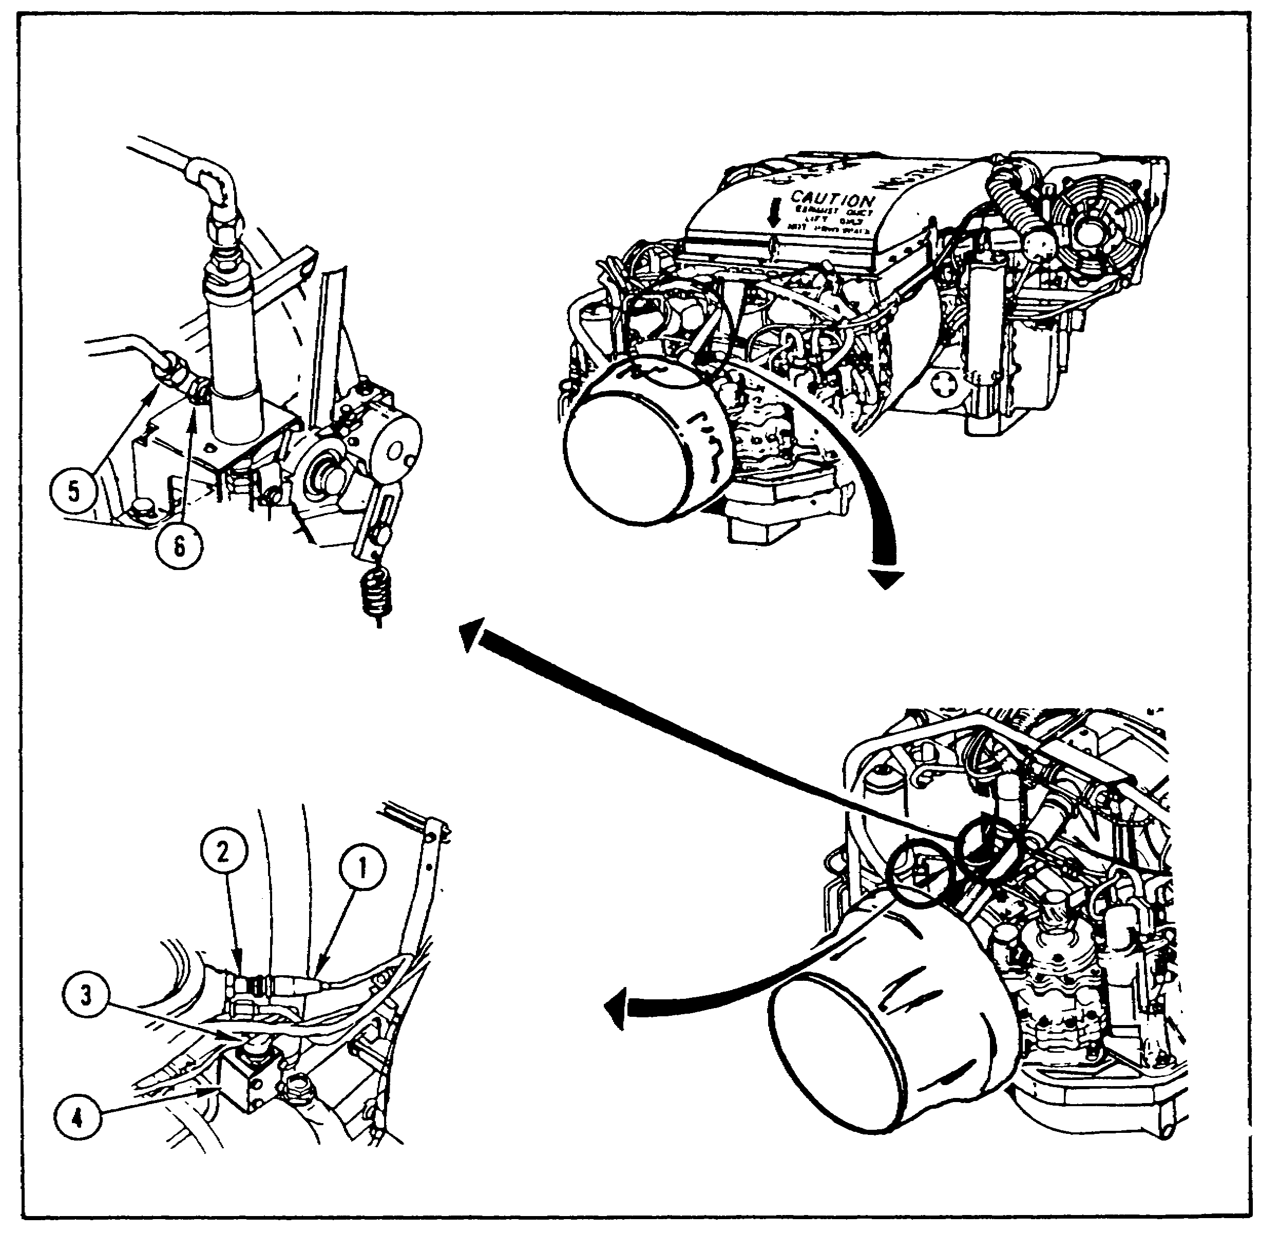
FIGURE 1. INITIAL IGV REMOVAL STEPS.

Next, the mechanic removes the tube nut (1, figure 2, on the following page) from the adapter (2) at the top of the shaft, using 5/8 inch and 11/16 inch wrenches. Diagonal cutting pliers are used to remove the cotter pin (3) from the straight pin (4) at the bottom of the shaft; the cotter pin is discarded. The mechanic then removes the washer (5) from the straight pin and removes the straight pin.

Two bolts (6) and lockwashers (7) are removed from the underside of the shouldered shaft bracket (8) using a 1/2 inch socket, an extension, and a handle. The lockwashers are discarded. The tabs of the keywasher (9) are bent away from the bolt

3

IGV ASSY, M1 TANK - OD 0487 - LESSON 1/TASK 1

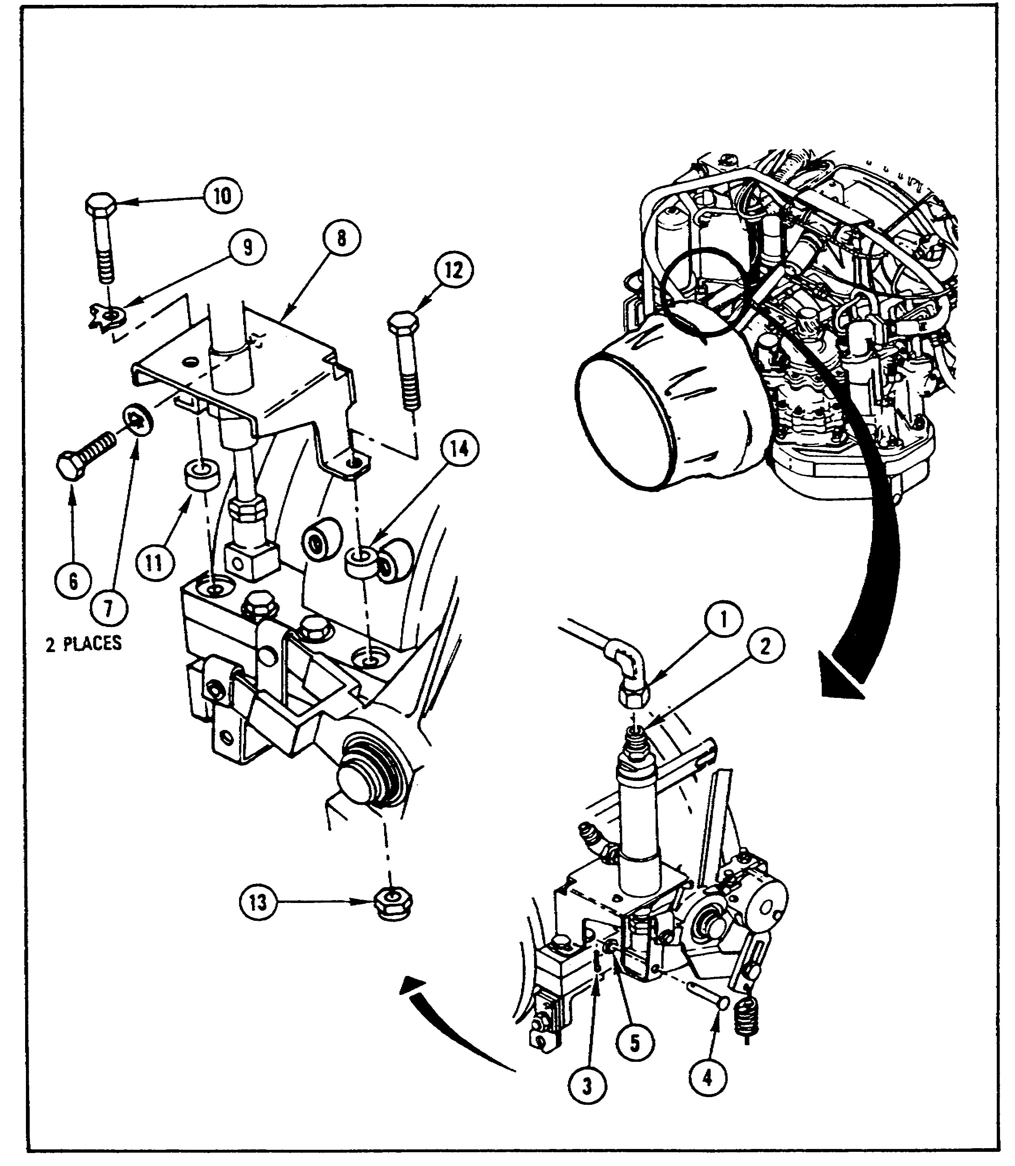
FIGURE 2. REMOVING SHOULDERED SHAFT FROM TANK.

(10) on the left side of the bracket, carefully, using a hammer and a punch. The bolt is then removed from the bracket with a 7/16 inch socket, an extension, and a handle. The keywasher and the spacer (11) are also removed; the keywasher is discarded. Then, using a 7/16 inch socket, an extension, and a handle, and a 5/16 inch wrench, the mechanic removes the bolt (12), self-locking

4

IGV ASSY, M1 TANK - OD 0487 - LESSON 1/TASK 1

nut (13), and spacer (14) from the right side of the bracket. The nut is discarded. This releases the IGV shouldered shaft bracket from the powerpack so that the shaft may be removed from the bracket.

After removing the shouldered shaft and bracket from the tank, the mechanic places the shaft (1, figure 3) and bracket (2) in a vise with the swivel coupling (3) and elbow (4) facing up, as in figure 3. Using two 5/8 inch wrenches, the mechanic loosens the nut (5) at the connector rod end (6), then removes the nut and the rod end from the stud (7) using 5/16 inch and 5/8 inch wrenches.

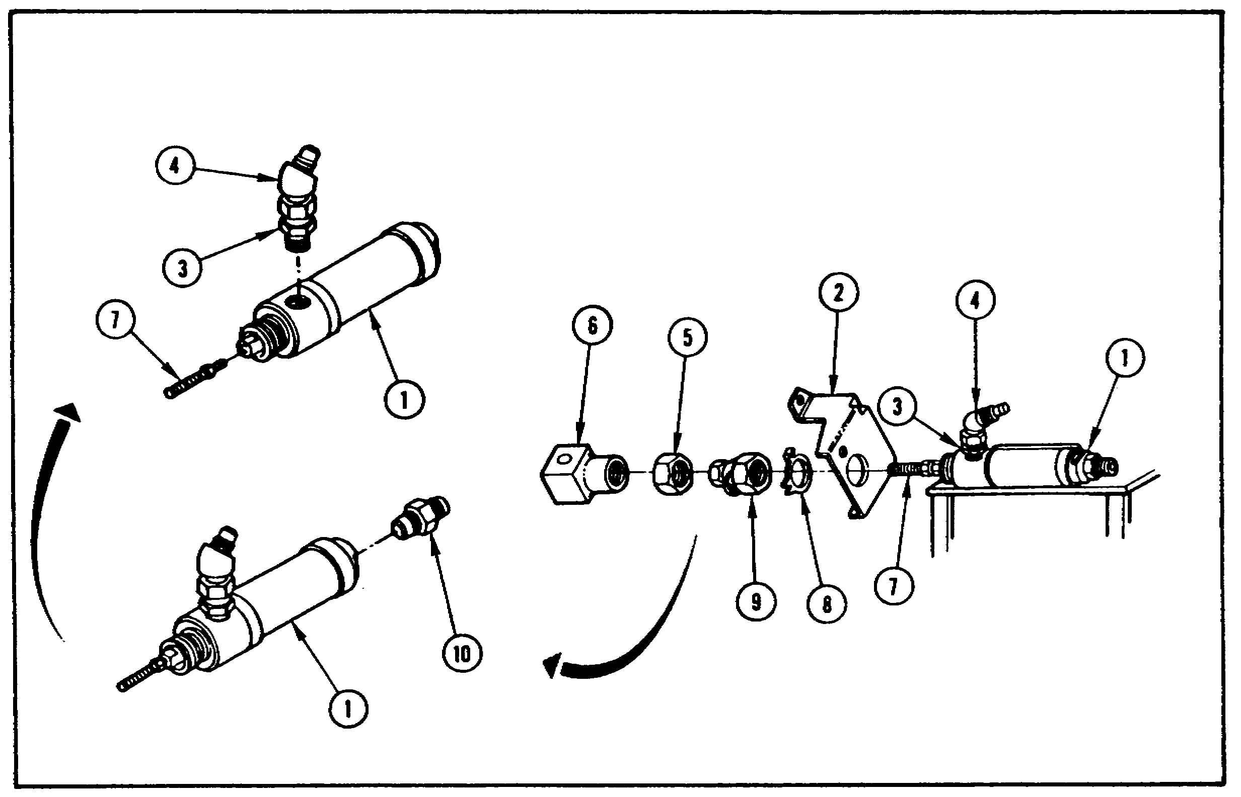
FIGURE 3. DISASSEMBLING SHOULDERED SHAFT.

The tabs of the keywasher (8) are bent away from the nut (9) with a hammer and punch. The nut and keywasher are removed from the shaft (1) with 1-1/16 inch and 7/8 inch wrenches. The keywasher is then discarded. The mechanic then removes the bracket (2) from the shaft. Using 5/8 inch and 7/8 inch wrenches, the mechanic removes the adapter (10) from the shaft. The swivel coupling (3) and elbow (4) are removed from the shaft with a 9/16 inch wrench. The stud (7) is removed from the shaft with 5/16 inch wrenches. Finally, the mechanic takes the shaft out of the vise and

5

IGV ASSY, M1 TANK - OD 0487 - LESSON 1/TASK 1

examines all the parts for breaks or stripped threads. Bad parts are turned in; good parts are set aside for later use.

b. Installation. The installation begins with the IGV shouldered shaft (1, figure 4) placed in a vise with the hole for the swivel coupling and the elbow (3) facing up. The coupling and elbow are screwed into the shaft and tightened using two 9/16 inch wrenches. The stud (4) is screwed into the shaft with 5/8 inch and 7/8 inch wrenches, then the adapter (5) is screwed into the shaft with 5/8 and 7/8 inch wrenches. The mechanic then places the shaft through the hole in the bracket (6). A new keywasher (7) is placed over the end of the shaft and against the bottom of the bracket. The keywasher tab (8) is inserted into its hole in the bracket. The mechanic then holds the keywasher in place and screws the nut (9) onto the shaft. The shaft is then removed from the vise.

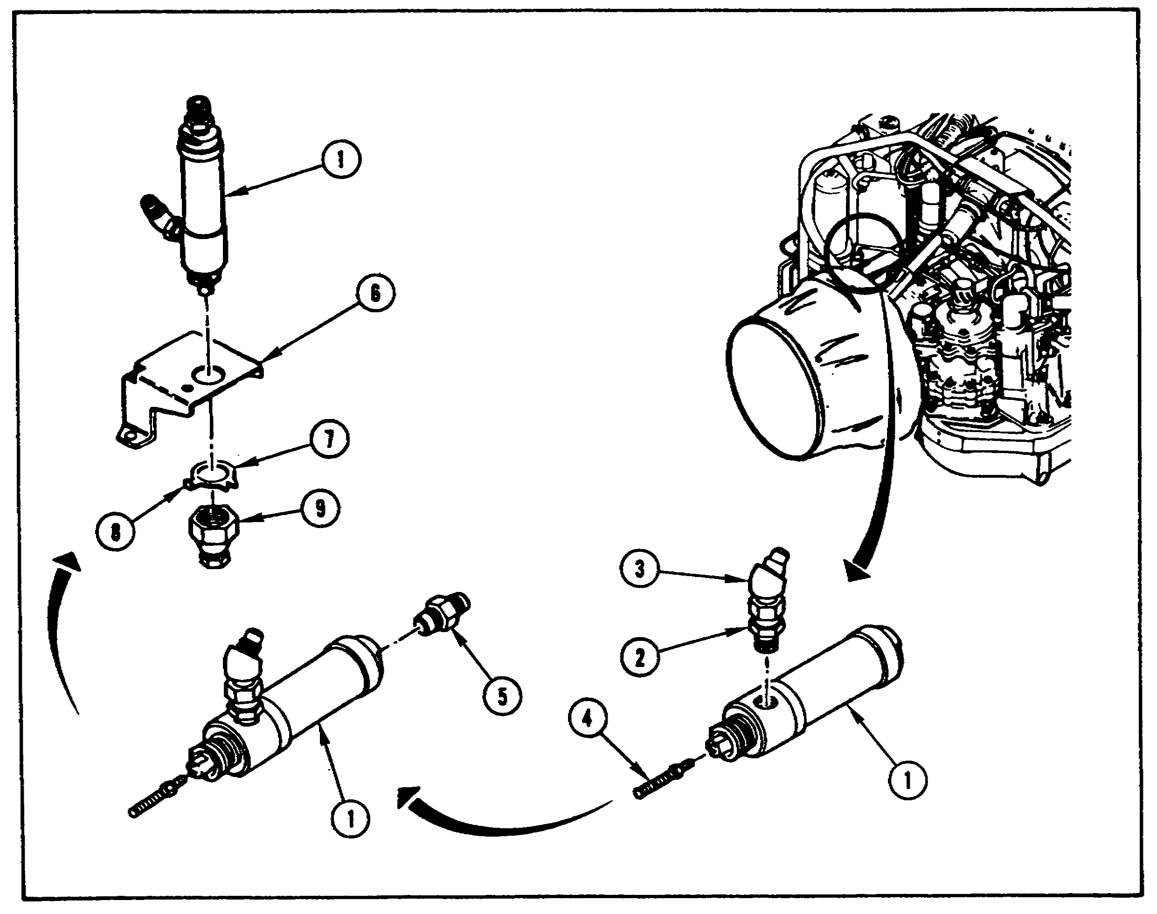
FIGURE 4. ASSEMBLING IGV SHOULDERED SHAFT.

6

IGV ASSY, M1 TANK - OD 0487 - LESSON 1/TASK 1

After assembling the IGV shouldered shaft, the mechanic places the bracket (1, figure 5), the shaft (2), and two spacers (3) in position on the engine. The left side bolt (4) and a new keywasher (5) are screwed into the engine with a 7/16 inch socket, an extension, and a handle. The mechanic does not tighten the bolt at this time. In the same way, the right side bolt (6) is screwed in along with a new self-locking nut (7), using a 7/16 inch socket, an extension, a handle, and a 5/16 inch wrench.

Two bolts (8) and new lockwashers (9) are used to secure the underside of the bracket; these are screwed in and tightened using a 1/2 inch socket, an extension, and a handle. The mechanic then tightens the left and right side bolts (4 and 6) in the bracket using a 7/16 inch socket, an extension, a handle, and a 5/16 inch wrench. The mechanic then bends the tabs on the keywasher up against the bolt using a hammer and a punch.

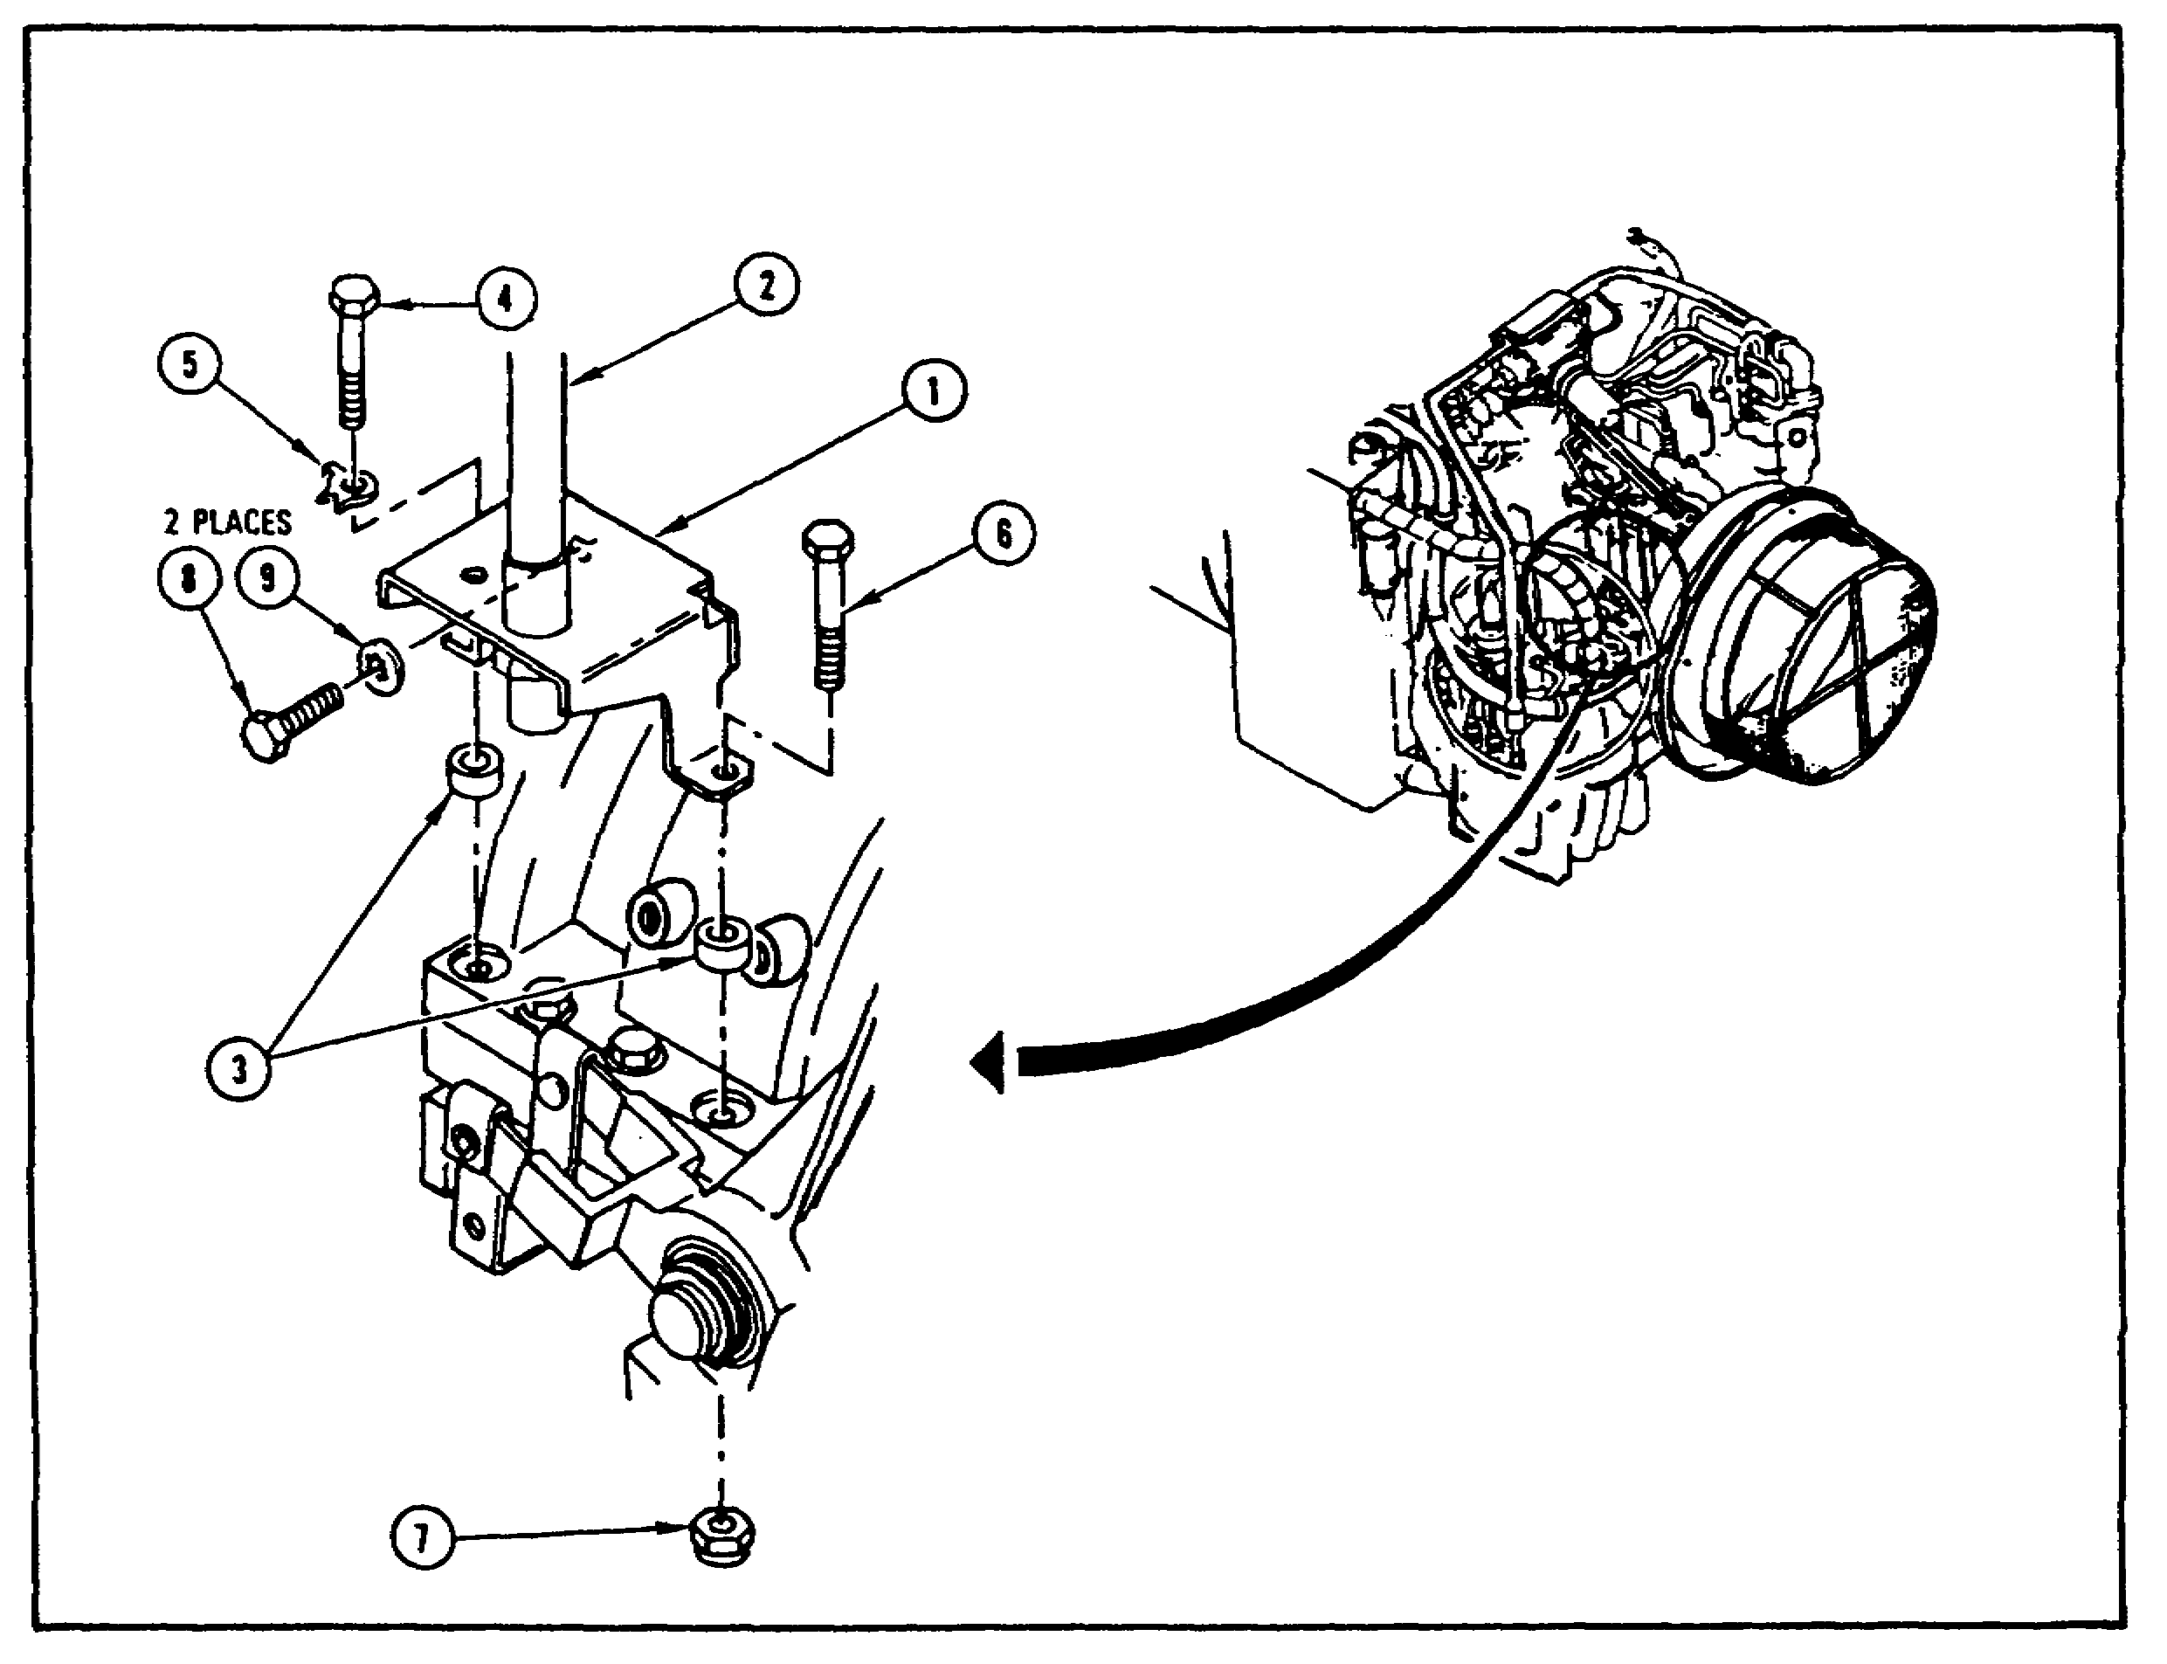

FIGURE 5. INSTALLING SHOULDERED SHAFT TO TANK.

7

IGV ASSY, M1 TANK - OD 0487 - LESSON 1/TASK 1

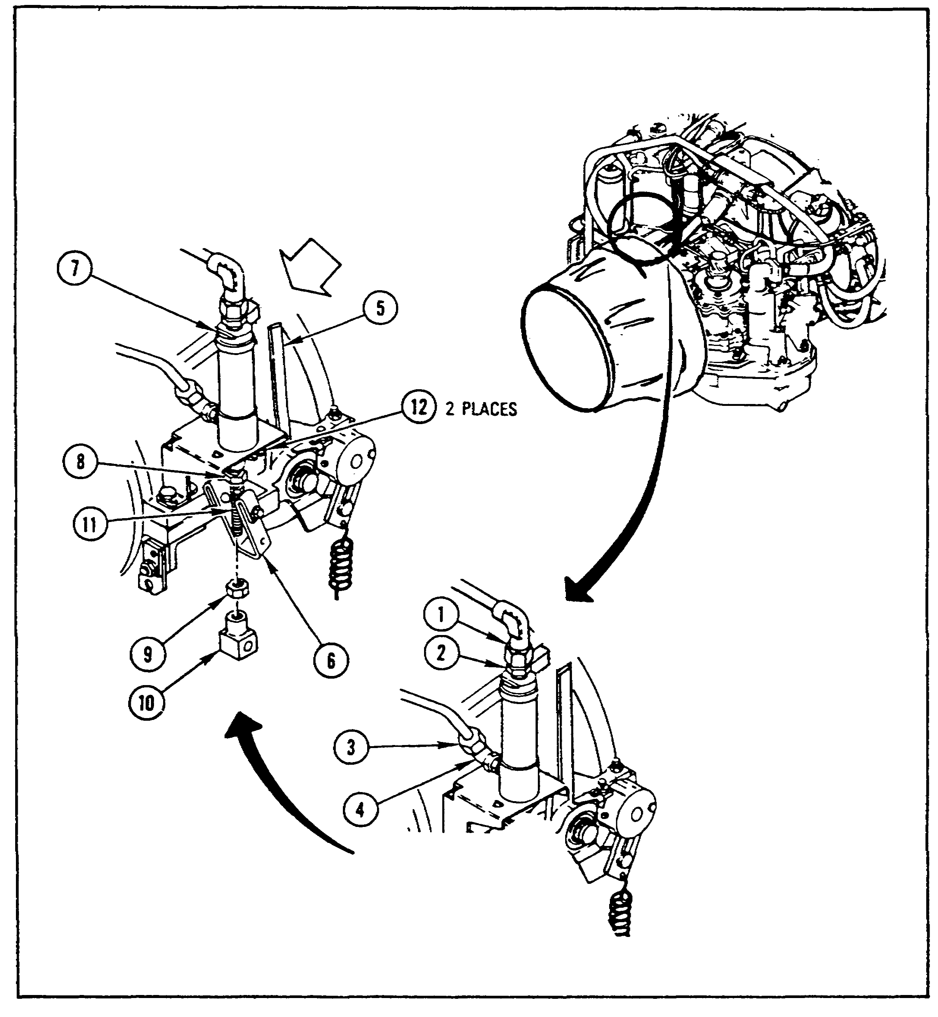
FIGURE 6. CONNECTING SHOULDERED SHAFT TUBES.

The mechanic then threads the tube nut (1, figure 6) onto the adapter (2) at the top of the shaft using 5/8 and 11/16 inch wrenches; this tube nut is not immediately tightened. The elbow tube nut with a new conical seal (3) is screwed and tightened onto the elbow (4) with 9/16 and 11/16 inch wrenches'. The type nut (1) is then tightened onto the adapter (2) using 5/8 and 11/16 inch wrenches. The mechanic then pushes the lever (5) all the way to the rear; the arrow in figure 6 indicates the rearward direction. The link (6) is then pushed

8

IGV ASSY, M1 TANK - OD 0487 - LESSON 1/TASK 1

forward. The mechanic holds the top of the shaft (7) with a 7/8 inch wrench, then uses a 1-1/16 inch wrench to tighten the jamnut (8) at the top of the stud.

The lower shaft nut (9) and rod end connector (10) are screwed onto the stud using 5/8 and 5/16 inch wrenches. The lower nut is then tightened against the connector with two 5/8 inch wrenches. Then, two tabs (12) are bent against the jamnut (8) with a screwdriver.

After installing the IGV shouldered shaft onto the engine, the shaft must be adjusted. The mechanic needs an assistant for the adjustment procedure.

The assistant pulls the actuator lever (1, figure 7) all the way forward and holds it in place. The mechanic uses a 3/8 inch wrench and loosens the self-locking nut (2). The adjusting screw (3) is turned clockwise or counterclockwise, whichever is needed, to line up the CLOSED mark (4) on the bellcrank (5) with the indicator (6) on the vane stop plate (7). The mechanic then holds the screw in place and tightens the nut.

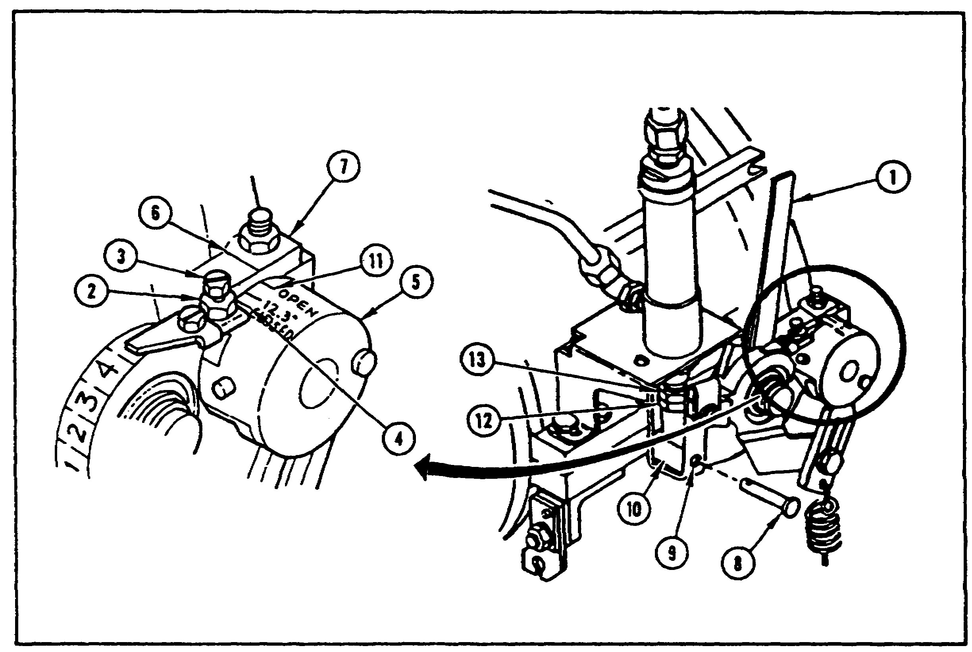

FIGURE 7. ALIGNING BELLCRANK INDICATORS.

9

IGV ASSY, M1 TANK - OD 0487 - LESSON 1/TASK 1

The mechanic pushes the straight pin (8) through the link (9) and the rod end connector (10). The assistant pushes the lever (1) all the way to the rear and holds it in place. The mechanic then looks at the OPEN mark (11) on the bellcrank (5) and the indicator (6) on the vane stop plate (7). If the marks are not aligned, the mechanic pulls the pin out of the link and the connector. While pushing the link all the way forward, the mechanic pushes the connector all the way down with a screwdriver. If the OPEN mark on the bellcrank is in front of the indicator, the shaft nut (12) and rod end connector are turned clockwise. If the OPEN mark is behind the indicator, the nut and connector are turned counterclockwise. The nut and connector are given one turn at a time until the open mark and the indicator are aligned.

After aligning the bellcrank indicators, or if the indicators did not need to be adjusted, the mechanic places a washer (1, figure 8 on the following page) on the straight pin (2), and places a new cotter pin (3) through the straight pin with a pair of pliers. The assistant pushes the lever (4) all the way to the rear and holds it there. The mechanic then checks the 4 mark (5) to see if it lines up with the indicator plate (6). If not, the mechanic loosens the indicator plate adjusting screw (7) with a screwdriver, lines up the plate with the mark, and tightens the screw.

After adjusting the plate, or if the plate did not need to be. adjusted, the assistant pulls the lever forward until the adjusting screw (8) is against the nut (9) and holds it in place. If the 2 mark (10) does not line up with the indicator plate, the mechanic pulls out the locking clip (11) with pliers and turns the adjusting screw clockwise or counterclockwise with a 5/8 inch wrench until the 2 mark lines up with the plate. The mechanic then turns the screw to the nearest flat and installs the locking clip. After this adjustment, or if this adjustment was not necessary, the mechanic screws plug P9 (12) onto the oil temperature transmitter (13), and plug P7 (14) onto the bypass pressure switch.

Once the mechanic has performed all the steps given above, he has essentially completed the removal and installation of the inlet guide vane shouldered shaft. There are 13 follow-on tasks listed after

10

IGV ASSY, M1 TANK - OD 0487 - LESSON 1/TASK 1

the installation of the shouldered shaft. These follow-on tasks are:

- Install starter motor

- Connect tank power

- Connect ground hop kit

- Perform inlet guide vane/power turbine stator (IGV/PTS) adjustments

- Disconnect ground hop kit

- Install powerpack

- Install engine step plate

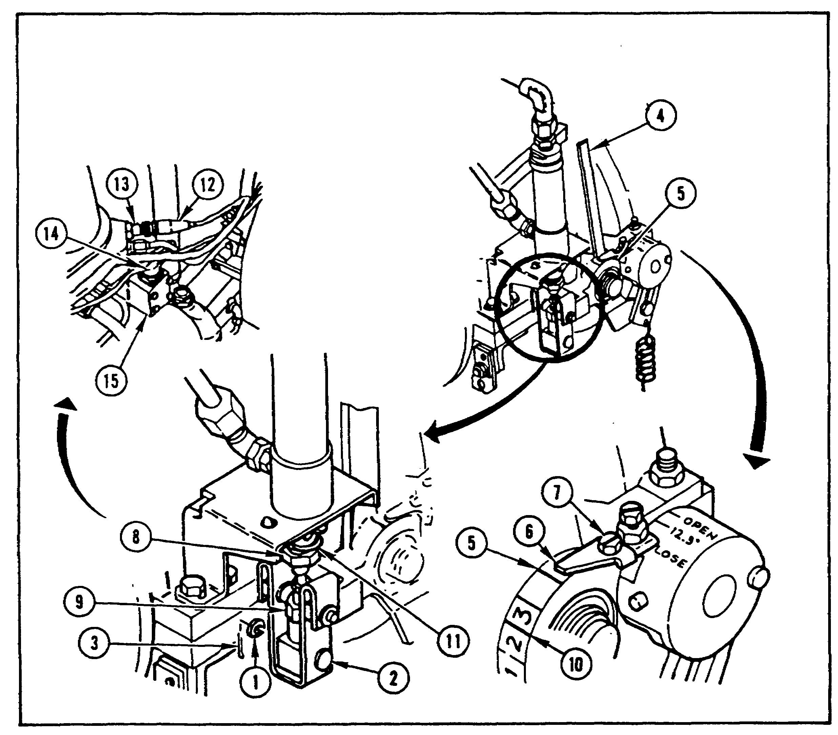
FIGURE 8. ADJUSTING IGV SHOULDERED SHAFT.

11

IGV ASSY, M1 TANK - OD 0487 - LESSON 1/TASK 1

- Install top deck and grilles

- Close rear metal grilles

- Close top deck left and right grille doors

- Close both precleaner doors

- Close both battery covers

- Install engine access cover

The IGV/PTS adjustments form the content of lesson 1, task 2.

3. Replacing the IGV Actuator Lever and Link

Replacing the IGV actuator lever and link can be done independently of removing and installing the IGV shouldered shaft. The steps for removing and installing the actuator lever and link are presented below.

a. Removal. The preliminary procedures for removal of the actuator lever and link are the same as for the removal of the IGV shouldered shaft (see paragraph 2a). Three more preliminary procedures are specified in TM 9-2350-255-20-1-3-1 after removing the powerpack. Once the powerpack is removed, the mechanic removes the inlet guide vane angle indicator bracket, the plenum-to-engine plain seal, and the engine air inlet screen assembly. The mechanic is then ready to remove the IGV actuator lever and link.

NOTE

The M1 tank may use either of two actuator levers (1 and 2, figure 9, on the following page). The procedures which follow illustrate both lever types and may be used for either type.

The mechanic unhooks the spring (3, figure 9) from the connecting link (4) with round nose pliers. The bolt (5), washer (6), spacer (7), and self-locking nut (8) are removed from the link with two wrenches; the nut is discarded.

12

IGV ASSY, M1 TANK - OD 0487 - LESSON 1/TASK 1

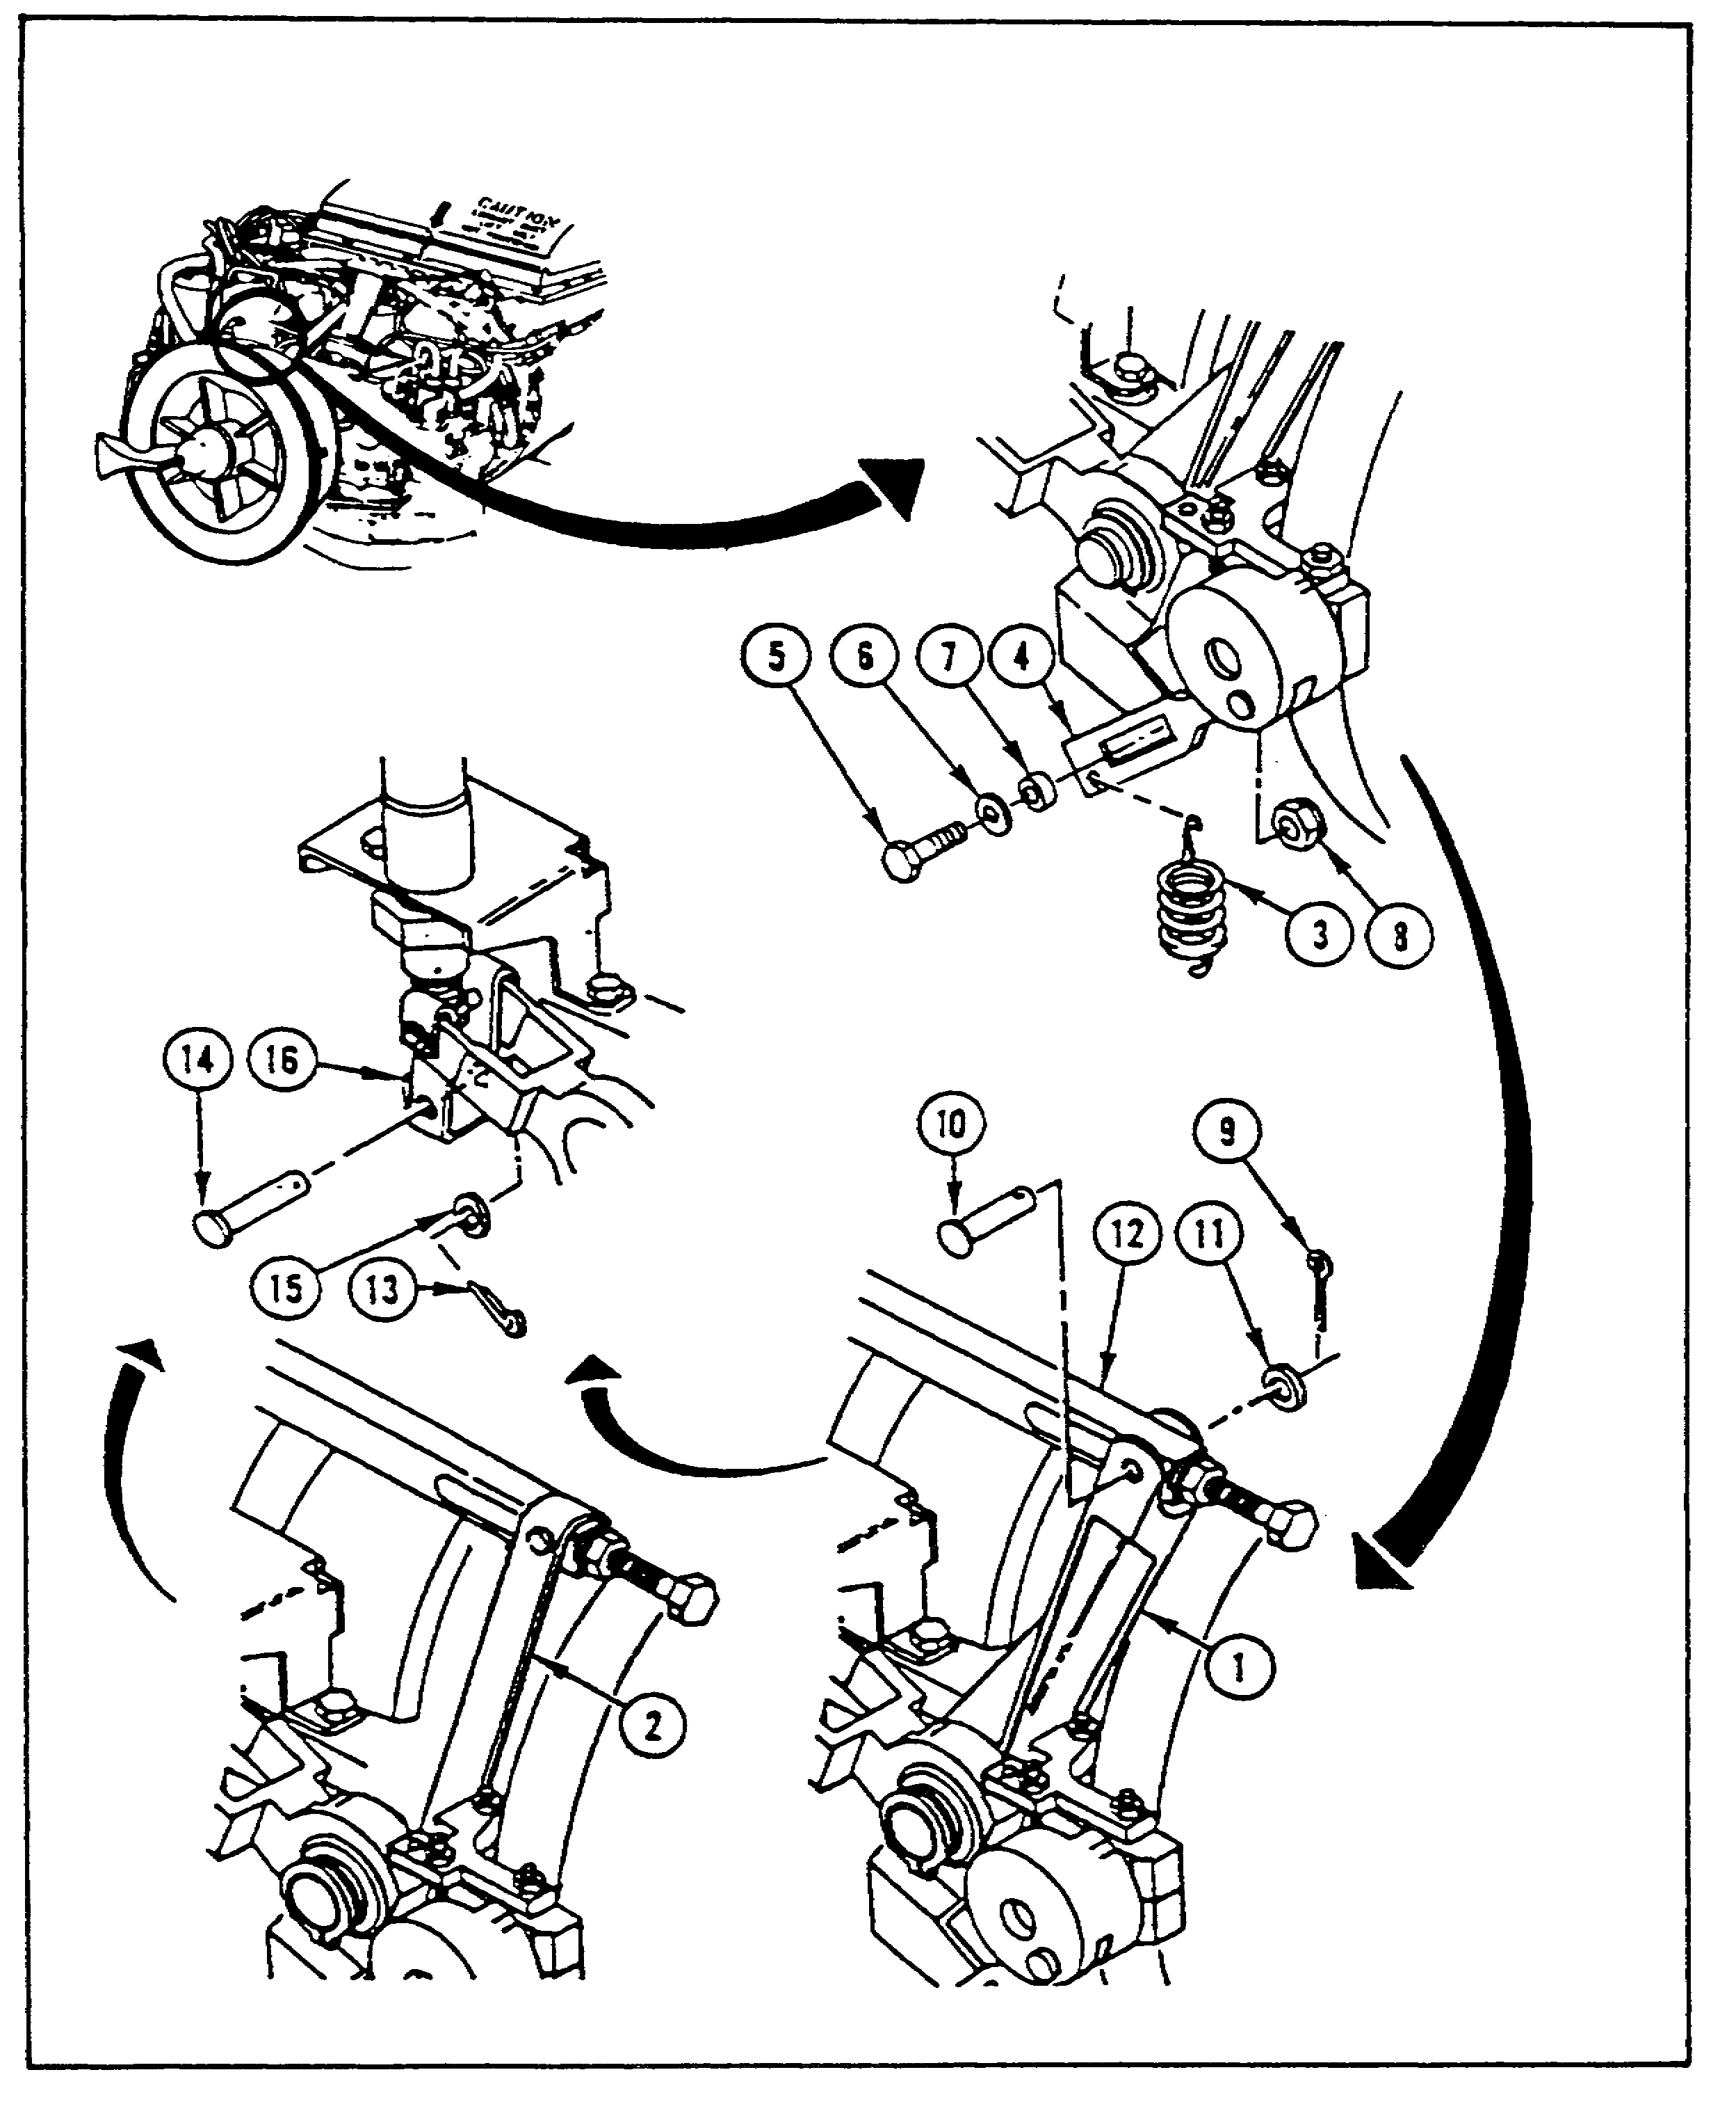
FIGURE 9. REMOVING LEVER AND LINK PINS.

Next, the mechanic takes the cotter pin (9) out of the straight pin (10) in the lever with round nose pliers. The straight pin and washer (11) are removed from the stud (12), and the cotter pin is discarded. Using round nose pliers, the mechanic then takes the cotter pin (13) out of the straight

13

IGV ASSY, M1 TANK - OD 0487 - LESSON 1/TASK 1

pin (14) in the rod end connector. The pin and its washer (15) are removed by moving the stud end (16) up or down as necessary. The cotter pin, as always, is discarded.

The mechanic then pushes in the button (1, figure 10) on the quick-release pin (2) and removes it from the lever (3) and control assembly (4). The retaining ring (5) is removed from the shaft (6) with retaining ring pliers. The mechanic then pulls the shim (7), bearing (8), lever, and washer (9) from the shaft. The shim is discarded.

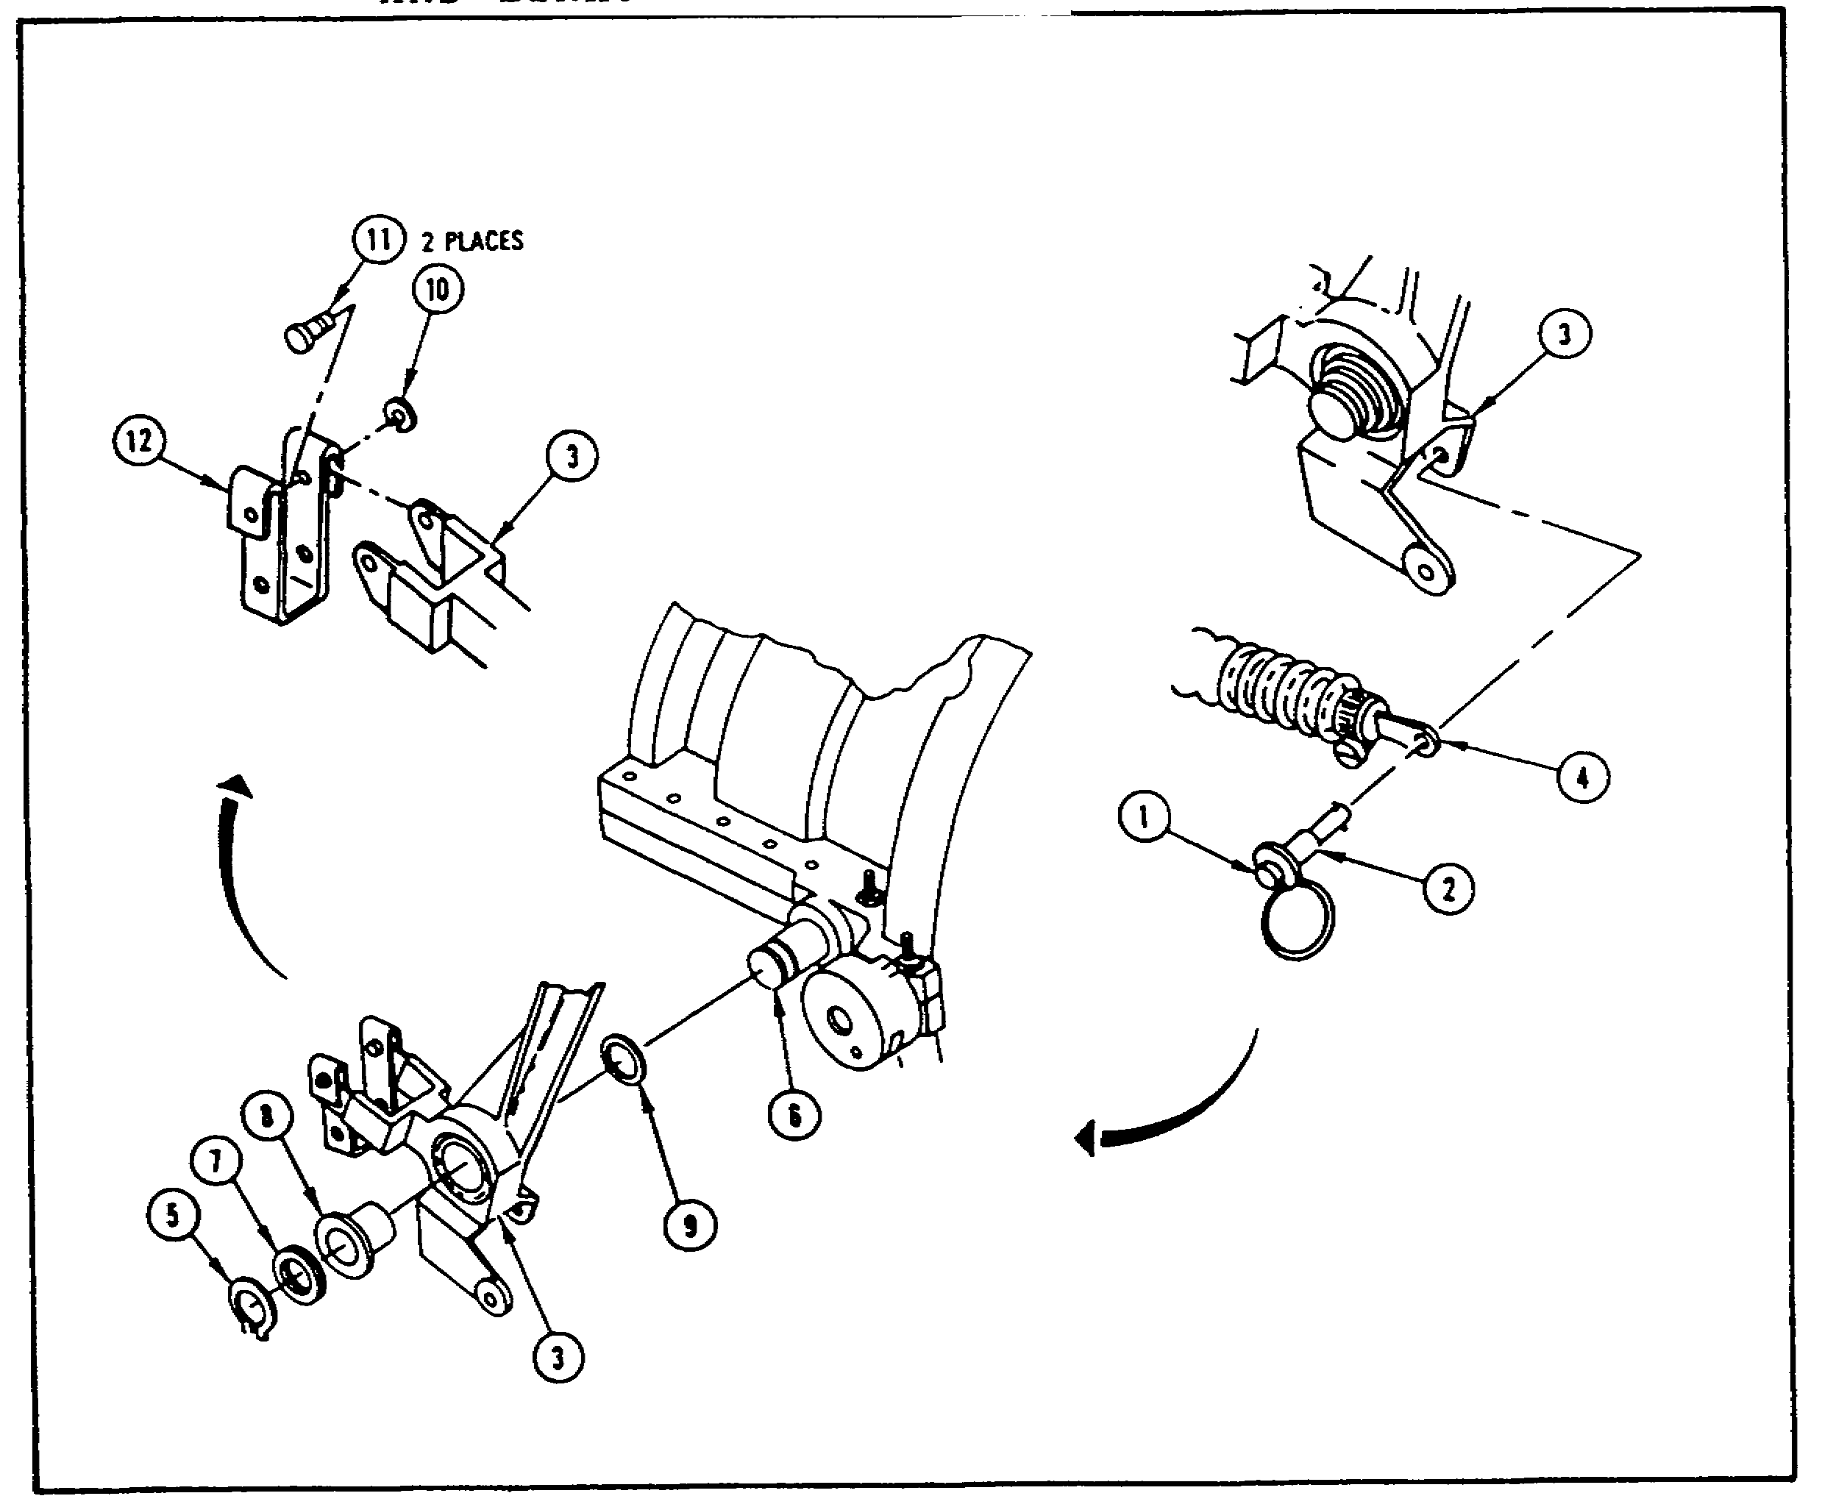
FIGURE 10. REMOVING ACTUATOR LEVER AND LINK.

The mechanic removes the two retaining rings (10) from the pins (11) with retaining ring pliers. The pins are then removed from the lever (3) and the actuator link (12). The mechanic inspects the lever and link for cracks, dents, or bends. Any bad parts in the lever and link assemblies are

14

IGV ASSY, M1 TANK - OD 0487 - LESSON 1/TASK 1

turned in through proper channels. Any good parts are set aside for use when the lever and link are reassembled.

b. Installation.

NOTE

The M1 tank may use either of two actuator levers (1 and 2, figure 11, on the following page). The procedures which follow illustrate both lever types and may be used for either type.

The mechanic places the actuator link (3, figure 11) on the lever (1 or 2). Two straight pins (4) are placed through the link and lever; two retaining rings (5) are placed on the pins with retaining ring pliers. A washer (6), the lever, a bearing (7), and a new shim (8) are placed on the shaft (9), and then layers are peeled off the shim until the retaining ring (10) will go on the shaft. Retaining ring pliers are then used to install the retaining ring.

The mechanic pushes in the button (11) on the quick-release pin (12) and pushes the pin through the control assembly (13) and lever (1 or 2). A straight pin (14) is placed through the link (3) and the stud end (15) of the shouldered shaft, with the stud end being moved as needed to permit assembly. A washer (16) and a new cotter pin (17) are placed on the straight pin with round nose pliers.

The lever (2, figure 12 on page 17) and stud (3) are connected- by a straight pin (1) inserted through them. The mechanic places a washer (4) and a new cotter pin (5) in the straight pin with round nose pliers. Next, the mechanic installs and secures a screw (6), washer (7), spacer (8), and new self-locking nut (9) into the connecting link (10) and lever (2), using two wrenches. The spring (11) is hooked onto the link with round nose pliers.

15

IGV ASSY, M1 TANK - OD 0487 - LESSON 1/TASK 1

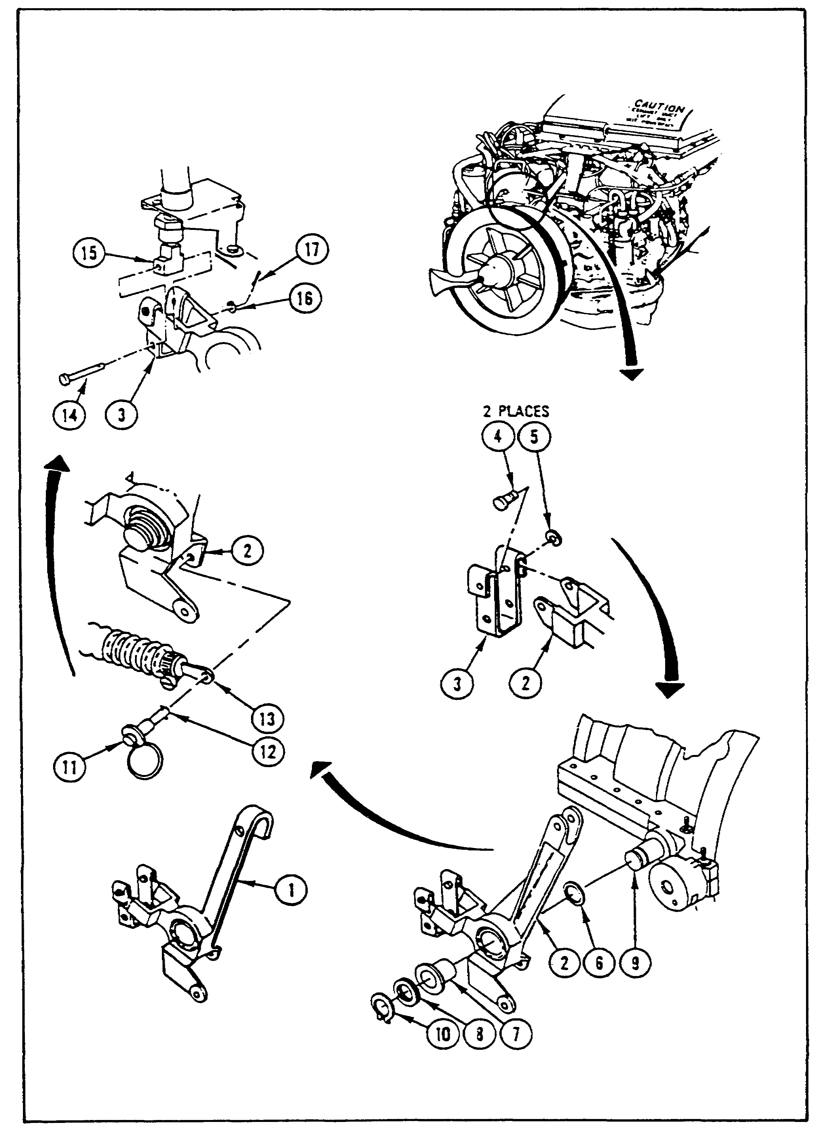
FIGURE 11. INSTALLING LINK AND LEVER.

16

IGV ASSY, M1 TANK - OD 0487 - LESSON 1/TASK 1

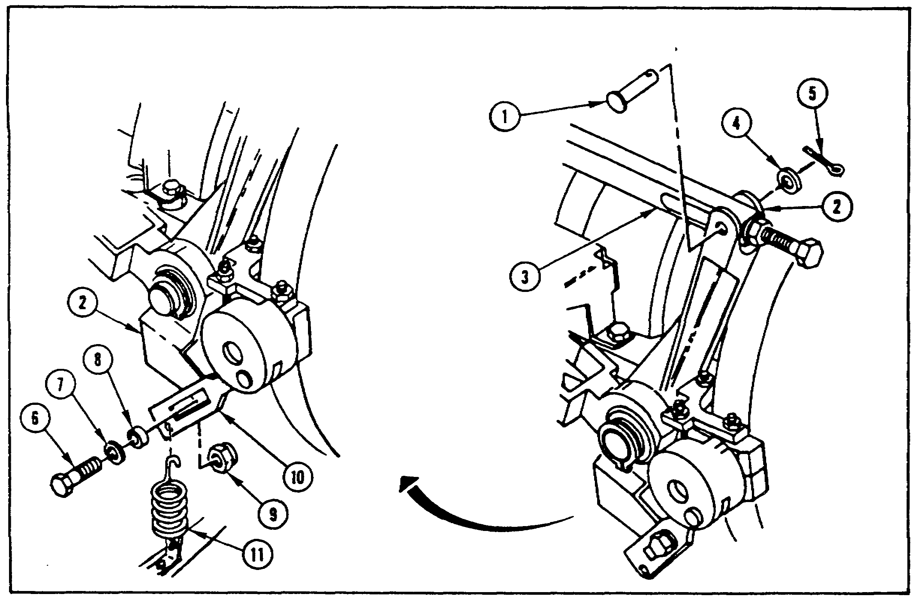
FIGURE 12. COMPLETING LEVER INSTALLATION.

After hooking the spring to the link, the mechanic is finished with the installation per se of the actuator lever and link. There is still the matter of 13 follow-on tasks to be performed to put the tank back into working order. These tasks include:

- Install engine air inlet screen assembly

- Install inlet guide vane angle indicator bracket

- Connect ground hop kit

- Adjust inlet guide vane feedback voltage

- Disconnect ground hop kit

- Install powerpack

- Install engine step plate

- Install top deck and grilles

- Close rear metal grilles

- Close top deck left and right grille doors

17

IGV ASSY, M1 TANK - OD 0487 - LESSON 1/TASK 1

- Close both precleaner doors

- Close both battery covers

- Install engine access covers

The adjustment procedures for the inlet guide vane feedback voltage are presented in the task which follows.

4. Conclusion

The M1 Abrams tank systems mechanic is responsible for repair or replacement of the inlet guide vane (IGV) shouldered shaft and the IGV actuator lever and link on the tank. This task has presented a brief overview of the theory of the IGV assembly, and has presented removal and installation procedures for the shouldered shaft, actuator lever, and actuator link. After the shaft or the lever and link have been replaced, the mechanic is required to perform follow-on tasks in which the inlet guide vane/power turbine stator (IGV/PTS) voltages are adjusted. Description of these tasks forms the content of the next task.

18

IGV ASSY, M1 TANK - OD 0487 - LESSON 1/TASK 2

LESSON 1

THE PROCEDURES FOR REMOVAL AND INSTALLATION OF THE
INLET GUIDE VANE SHOULDERED SHAFT, ACTUATOR LEVER
AND LINK, AND THE PROCEDURES FOR ADJUSTING THE
INLET GUIDE VANE ASSEMBLY VOLTAGE USING THE
SIMPLIFIED TEST EQUIPMENT M1/FVS (STE-M1/FVS)

TASK 2. Describe the procedures for operating the STE-M1/FVS and adjusting the inlet guide vane voltage.

CONDITIONS

Within a self-study environment and given the subcourse text, without assistance.

STANDARDS

Within three hours

REFERENCES

No supplementary references are needed for this task.

1. Introduction

The previous task described the procedures required to remove and install both the inlet guide vane (IGV) shouldered shaft and the IGV actuator lever and link. In the course of describing those procedures, it was noted that follow-on tasks common to both installation procedures was adjusting the IGV voltage, which is also called the IGV/PTS voltage (PTS meaning power turbine stator).

The IGV/PTS adjustment procedure uses the simplified test equipment for the M1 and fighting vehicle systems test set--commonly called the STE-M1/FVS, or sometimes STE for short. In making the IGV/PTS adjustments, the technical manual (TM) is organized as a flow chart which asks the mechanic many questions. The description presented here will take the mechanic down one possible course through the chart. It should be noted here, though, that the mechanic's actual path through the

19

IGV ASSY, M1 TANK - OD 0487 - LESSON 1/TASK 2

flow chart, just like a troubleshooting flow chart, will depend on the readings he gets from an actual M1 tank with a real STE test set connected to it.

2. Adjusting the Inlet Guide Vane Voltages

The entire adjustment flow chart appears at the end of this task, essentially as it appears in TM 9-2350-255-20-1-2-2. Block numbers, questions, and YES or NO branches in the text come from this flow chart, and the reader will be directed to it. Block numbers in the text from this point on refer to figure 13, which is the adjustment flow chart.

NOTE

The flow chart (figure 13 on pages 25 through 38) gives instructions for adjusting both the inlet guide vane (IGV) and the power turbine stator (PTS) voltages. This discussion will deal only with the IGV adjustments.

After obtaining the common tools, supplies, and test equipment specified in the beginning of the flow chart (figure 13), the mechanic is instructed to park the tank, set the parking brake, shut down the engine, and turn off vehicle master power. Then, the flow chart tells him, in block 1, to set up the tank controls for standard initial test conditions. These initial conditions cover six pages in the TM cited above; they are summarized in table 1.

Table 1. Standard Initial Test Conditions

Location Conditions

Commander's Station TURRET POWER to OFF
VEHICLE MASTER POWER to
OFF
PANEL LIGHTS control to
maximum clockwise
position

Gunner's Station DEFROSTER to OFF
PANEL LIGHTS control to
maximum clockwise
position
THERMAL MODE to OFF

20

IGV ASSY, M1 TANK - OD 0487 - LESSON 1/TASK 2

Table 1. Standard Initial Test Conditions
(Continued)

Location Conditions

Gunner's Station RETICLE control to
(continued) maximum clockwise
position
Ballistics Computer PWR
to OFF
Laser Rangefinder to SAFE
Internal gun travel lock
engaged

Loader's Station All turret networks box
circuit breakers ON
TURRET BLOWER to OFF
GUN/TURRET DRIVE to
POWERED
Turret lock to LOCKED

Driver's Station All switches to OFF
except as noted
PERSONNEL HEATER HIGH/LOW
to LOW
PANEL LIGHTS control to
maximum clockwise
position
TANK SELECTOR to REAR
2ND SHOT guard closed
All hull networks box and
power distribution box
circuit breakers ON

Once the standard initial test conditions are established in the tank, the mechanic proceeds to block 2 (page 26) of the flow chart. There he finds directions for checking the CLOSED position of the IGV bellcrank. The block asks "Are marks lined up in CLOSED position?"

Since the previous task included adjusting the IGV bellcrank, our answer is YES, so we go to block 3. The mechanic is then directed to check the OPEN position of the bellcrank. The flow chart asks "Are marks lined up in OPEN position?"

Descriptions for making this adjustment were contained in the previous task; so we answer YES and go to block 5. The mechanic then checks the position of the 4 mark and angle indicator bracket. "Does angle indicator bracket line up with 4 mark?"

21

IGV ASSY, M1 TANK - OD 0487 - LESSON 1/TASK 2

the chart asks. YES, our mechanic answers, and goes to block 7.

Block 7 directs the mechanic to check the position of the 2 mark and indicator bracket. When the flow chart asks if the marks line up, the mechanic answers YES and proceeds to block 10 (page 27). There the mechanic finds a procedure for checking the position of the 3 mark and indicator bracket by removing the air bleed tube assembly. Notice that block 10 does not give the directions for removing the air bleed tube assembly, only the location of the directions. The mechanic would need to go to the specified paragraph in the specified technical manual (TM) for the directions to remove the air bleed tube assembly.

NOTE

The IGV voltage adjustments are part of the follow-on procedures for removing and installing both the IGV shouldered shaft and the IGV actuator lever and link. Directions for removing the air bleed tube assembly specify removing the powerpack as a preliminary procedure. When performing the voltage adjustments as a follow-on to replacing the shouldered shaft or actuator lever and link, the powerpack is already removed from the vehicle.

Because, in this case, the 3 mark lines up with the bracket as expected, the mechanic installs the air bleed tube assembly according to the directions referenced in block 12, and then goes to block 13 (page 28). Block 13 directs the mechanic to prepare the STE for operation, then indicates the figure number in the same TM which gives those directions.

Once the STE is set up, block 14 directs the mechanic to enter test number 1522. The STE set communicator (SETCOM) responds with the display TEST 1522 IGV/PTS RIGGING. When the mechanic sees this display, he presses the GO key on the SETCOM (block 15). (In the NOTE below block 15, the flow chart tells the mechanic that it is possible for the SETCOM to display a message other than the cable connection messages which the chart presents in block 16. The mechanic is directed to perform an IGV/PTS RIGGING test according to instructions

22

IGV ASSY, M1 TANK - OD 0487 - LESSON 1/TASK 2

in another TM if any fault messages or any different cable connection messages appear. This discussion will not cover that possibility.)

After reading the NOTE, the mechanic should see that the first display after pressing the GO key is CONNECT CIB J2 (CX304) TO ECU J1 (CA604)(block 16). This means that the mechanic connects plug P2 of STE cable assembly CA604 (or CA604-P2) to J1 on the electronic control unit (ECU), that STE cable adapter CX304-P1 is connected to CA604-P1, and that CX304-P2 is connected to J2 on the controllable interface box (CIB). When the mechanic has completed these connections, he presses the GO key (block 17) and resumes the test.

In block 18 (page 29), the adjustment flow chart asks "Does display show ADJ IGV -11.0/-10.2V XX.X V?" Since the whole point of this task is to make the adjustments, we will assume that the display does come up as shown. Following the YES branch out of block 18, the mechanic sees a NOTE. This note tells him that the display shown informs him that the IGV feedback cable must be adjusted between -11.0 and -10.2 volts direct current (vdc). The second line tells him what the actual voltage is. The mechanic is told that the voltage will change as the adjustment is made. Observe the second note in this block: "It is only necessary to press and hold ENGINE SHUTOFF switch while checking voltage." A careful and thorough reading of this flow chart will not reveal a direction to press and hold the ENGINE SHUTOFF switch to make the voltage reading, but that is what the mechanic must do to obtain the actual value. The ENGINE SHUTOFF switch is found on the driver's master panel.

After reading the notes, the mechanic goes to block 20, which sends him to block 33 (page 34). Block 33 instructs the mechanic to perform the mechanical adjustments if they have not been performed previously. Since these adjustments were performed in the course of replacing the IGV shouldered shaft, they need not be repeated here. (Note that this is only true of replacing the shouldered shaft. If the actuator lever and link were replaced or if the mechanic is only performing a voltage check, the mechanical adjustments must be checked and/or performed before making the voltage adjustments.)

Block 33 then asks the mechanic if the voltage is greater than -11.0 vdc. Note the example which

23

IGV ASSY, M1 TANK - OD 0487 - LESSON 1/TASK 2

follows the question: The flow chart is looking for a greater negative voltage than -11.0 vdc, for example, -12.0 vdc. Either answer the mechanic gives requires an adjustment procedure. The only difference, though, is on which side of the plate the shims go. If the negative voltage is greater than -11.0 vdc, the mechanic removes shims from in front of the plate and places them between the plate and the bracket (block 34). If the voltage is less than -10.2 vdc, the mechanic removes shims from between the plate and the bracket and installs them in front of the plate (block 38 on page 35). The shims are removed one at a time.

Block 34 and block 38 both set up NO GO loops within themselves that require the mechanic to go back to the block and repeat the action until the voltage falls between -11.0 and -10.2 vdc. The mechanic then goes back to block 17 (page 28) and presses the GO key. To the question "Does display show ADJ IGV -11.0/-10.2V XX.X V?", the mechanic answers NO this time.

Notice block 19 (page 29). It asks the mechanic "Does display show ADJ IGV -1.20/-0.70V X.XX V?" This question is put to the mechanic because the actual voltage he is supposed to observe will depend upon the position of the actuator lever at the time the reading is taken. The -11.0/-10.2 vdc reading will be the more common reading, but the -1.20/-0.70 vdc reading is possible. The SETCOM will display either the question in block 18 or the one in block 19. The mechanic should not see both questions during the same adjustment procedure.

If the mechanic sees the SETCOM display in block 19 as opposed to the display in block 18, he is directed to block 41 (page 36). Block 41 essentially asks the same question that block 33 asks: is the actual voltage a greater negative voltage than that desired? If the answer to this question is YES, the mechanic is directed to block 42; if the answer is NO, he is directed to block 43, which leads to block 46 (page 37). These adjustment procedures are identical to those described earlier.

Once the adjustment has been made and the proper voltage reading obtained, the mechanic can complete the follow-on procedures for the IGV shouldered shaft or the IGV actuator lever and link.

24

IGV ASSY, M1 TANK - OD 0487 - LESSON 1/TASK 2

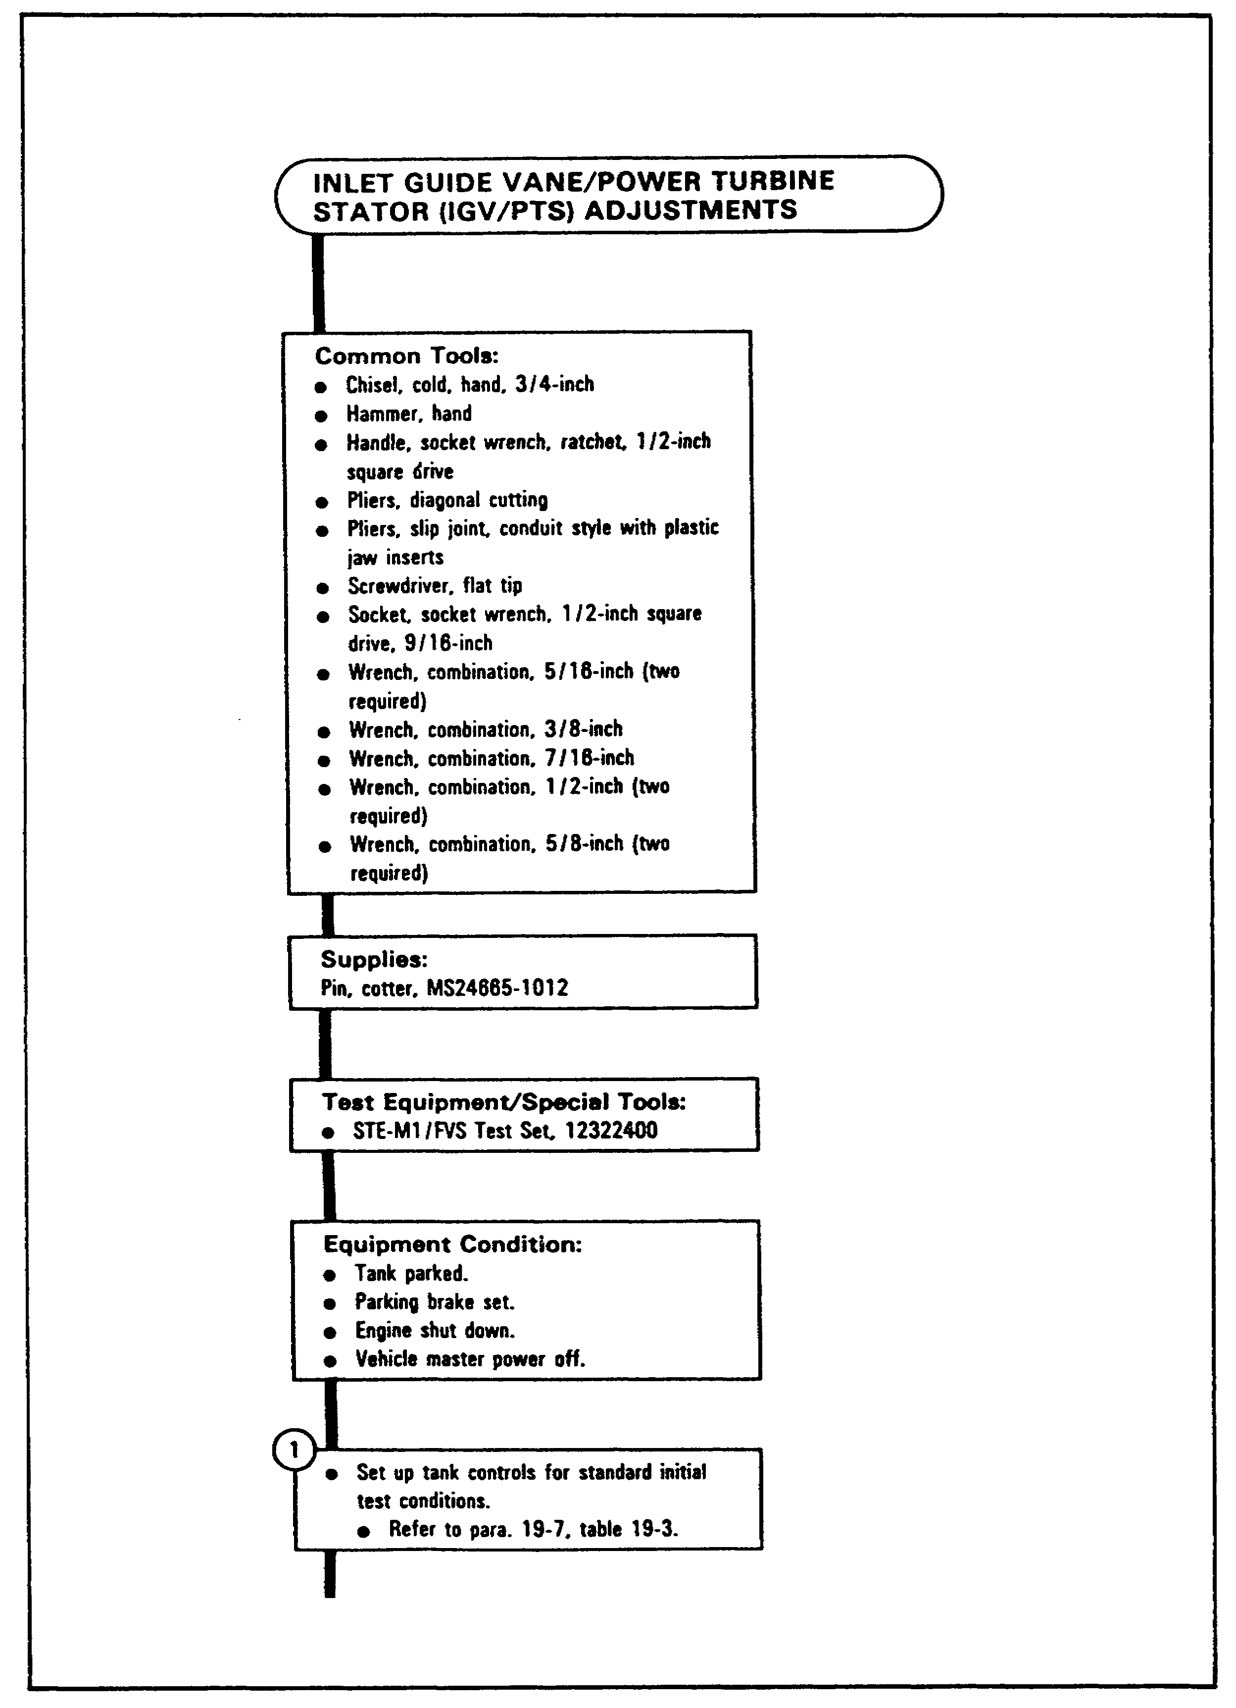

FIGURE 13. IGV ADJUSTMENT FLOW CHART.

25

IGV ASSY, M1 TANK - OD 0487 - LESSON 1/TASK 2

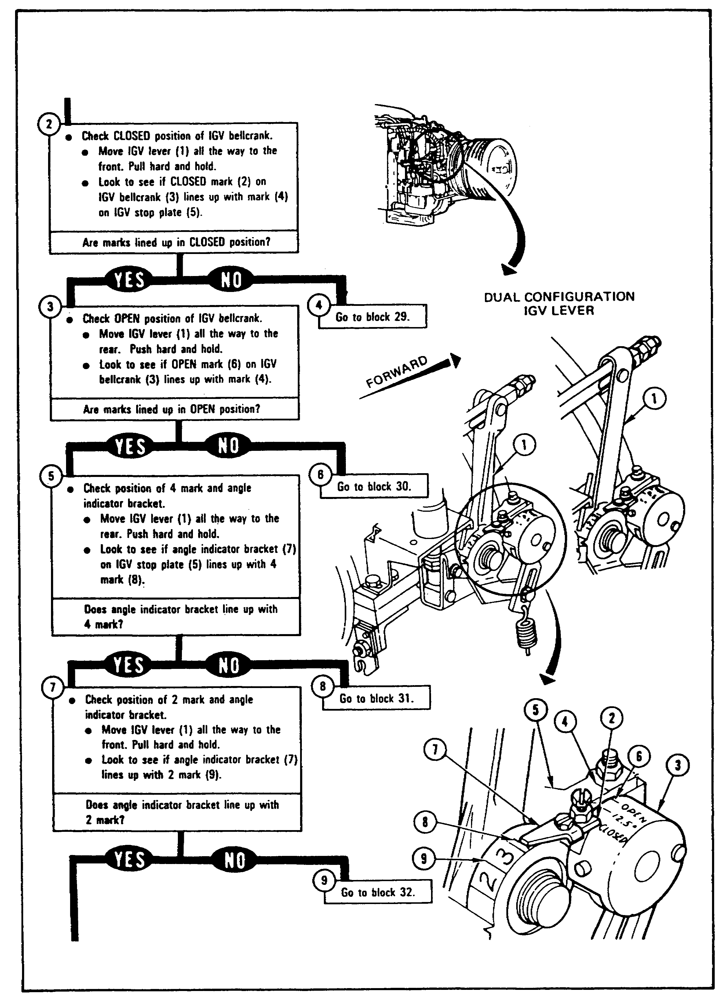
FIGURE 13. IGV ADJUSTMENT FLOW CHART
(CONTINUED).

26

IGV ASSY, M1 TANK - OD 0487 - LESSON 1/TASK 2

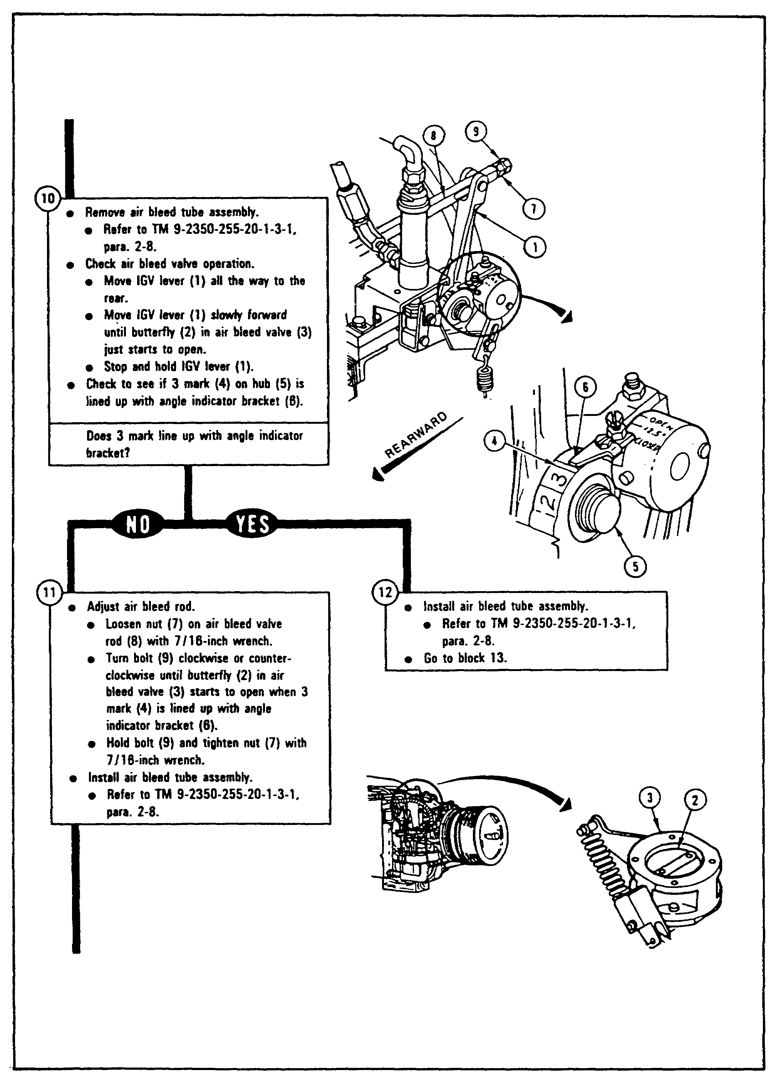
FIGURE 13. IGV ADJUSTMENT FLOW CHART
(CONTINUED).

27

IGV ASSY, M1 TANK - OD 0487 - LESSON 1/TASK 2

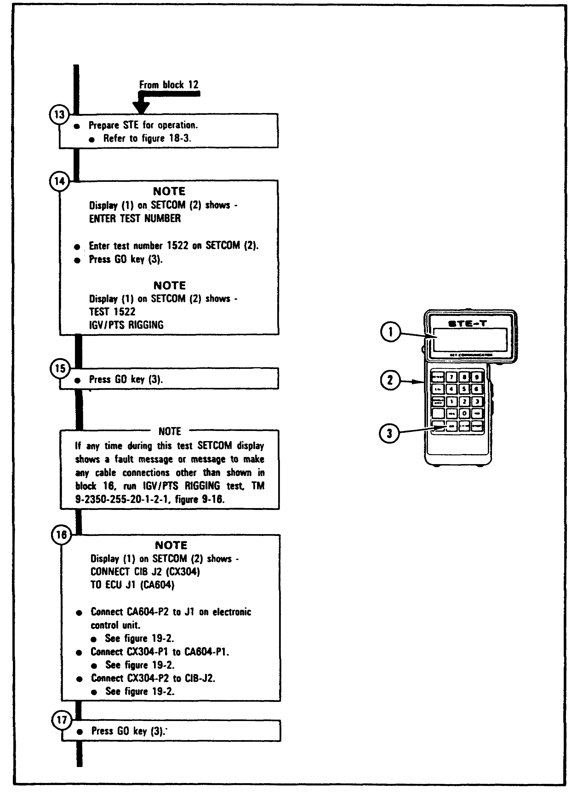
FIGURE 13. IGV ADJUSTMENT FLOW CHART
(CONTINUED).

28

IGV ASSY, M1 TANK - OD 0487 - LESSON 1/TASK 2

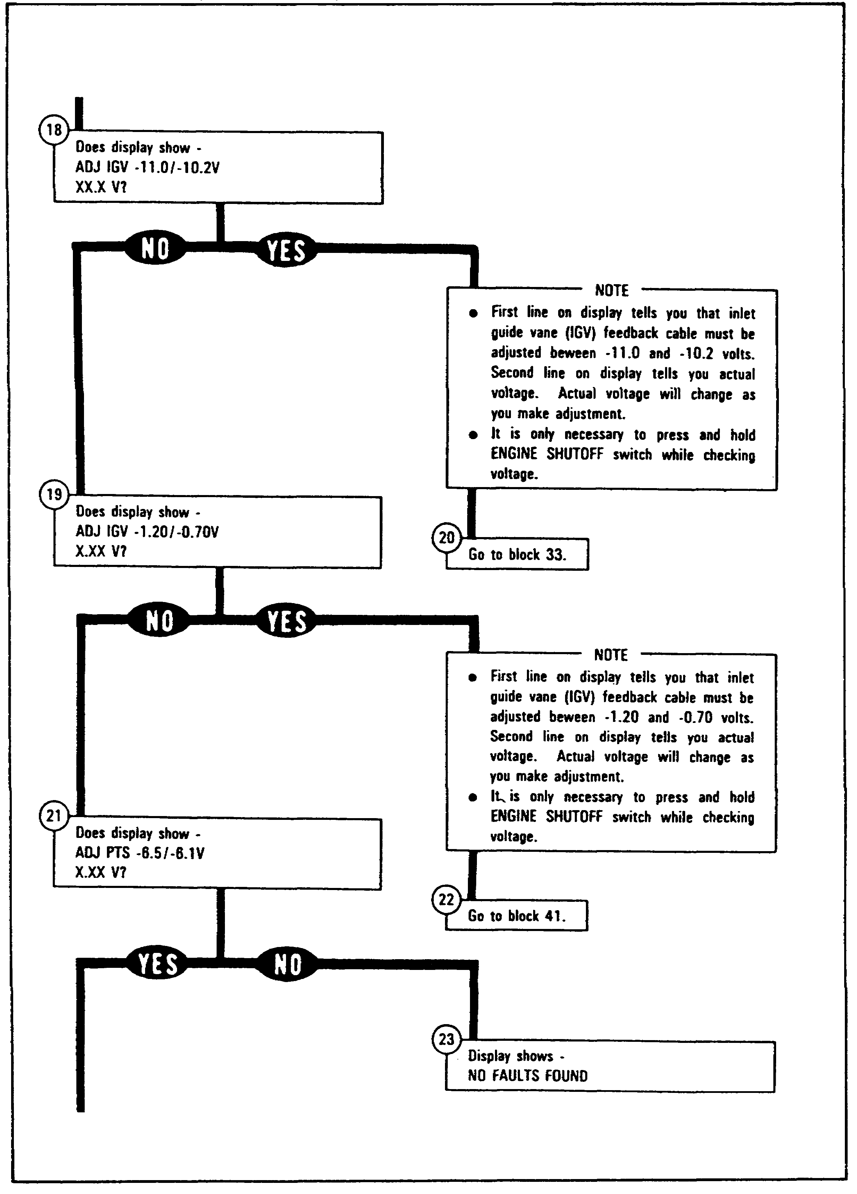
FIGURE 13. IGV ADJUSTMENT FLOW CHART
(CONTINUED).

29

IGV ASSY, M1 TANK - OD 0487 - LESSON 1/TASK 2

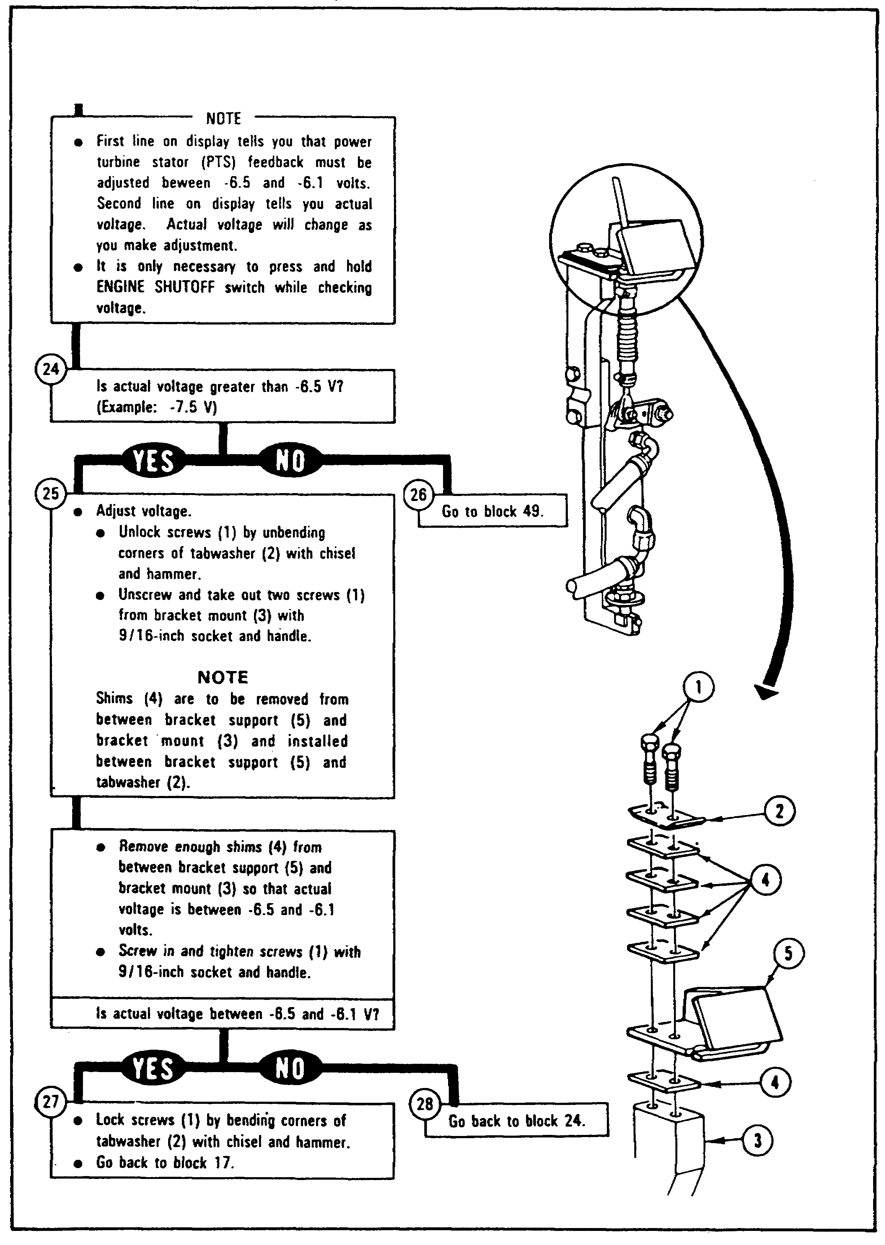
FIGURE 13. IGV ADJUSTMENT FLOW CHART
(CONTINUED).

30

IGV ASSY, M1 TANK - OD 0487 - LESSON 1/TASK 2

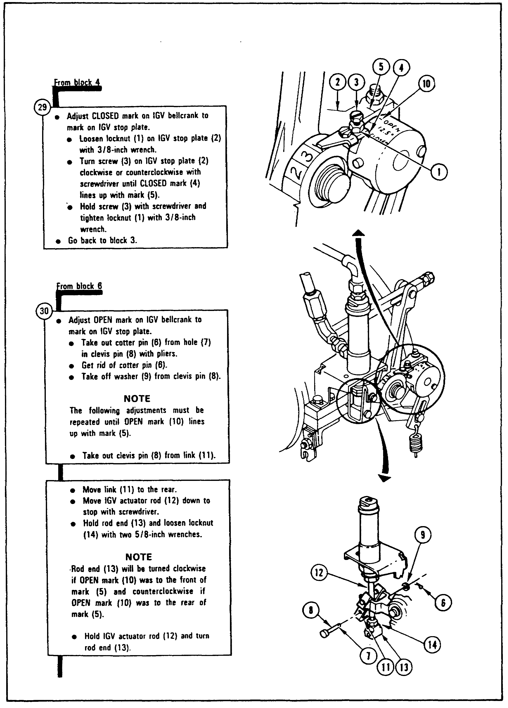
FIGURE 13. IGV ADJUSTMENT FLOW CHART
(CONTINUED).

31

IGV ASSY, M1 TANK - OD 0487 - LESSON 1/TASK 2

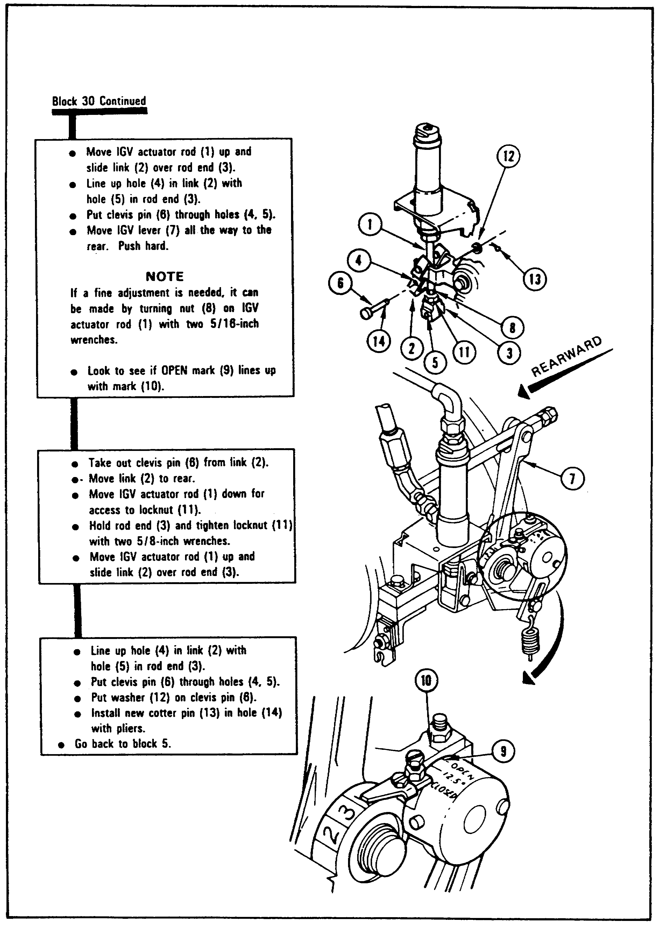
FIGURE 13. IGV ADJUSTMENT FLOW CHART
(CONTINUED).

32

IGV ASSY, M1 TANK - OD 0487 - LESSON 1/TASK 2

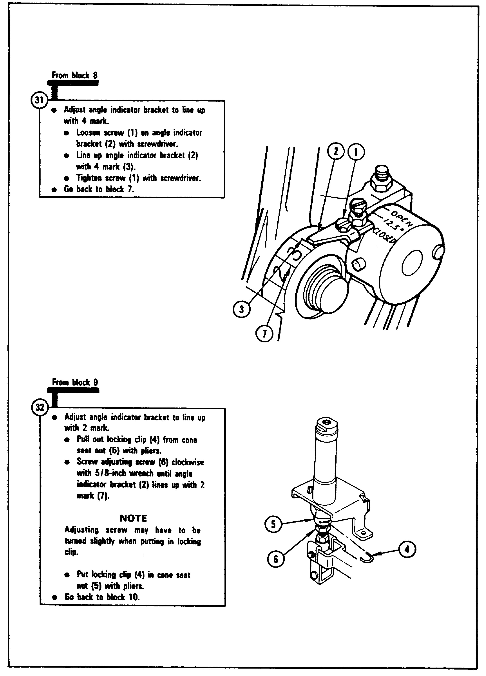
FIGURE 13. IGV ADJUSTMENT FLOW CHART
(CONTINUED).

33

IGV ASSY, M1 TANK - OD 0487 - LESSON 1/TASK 2

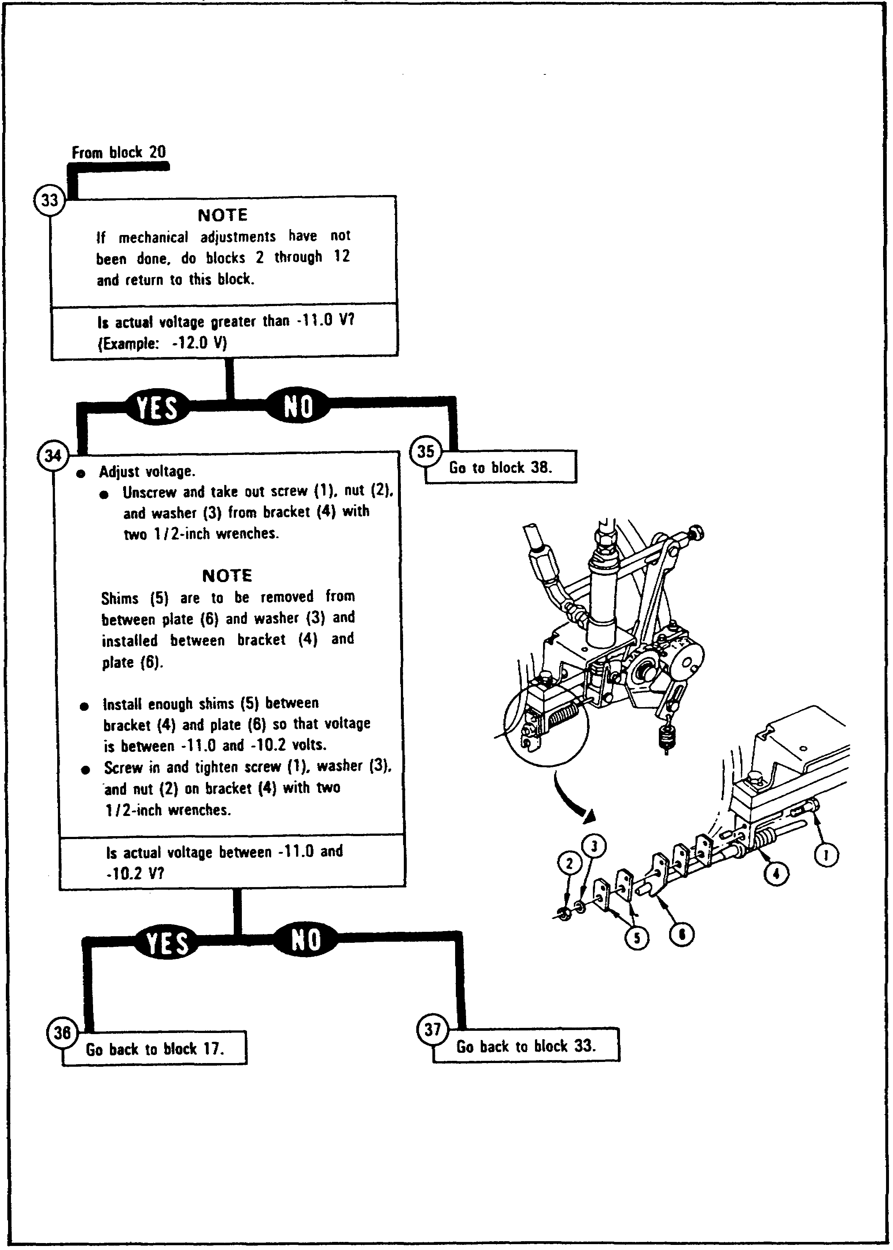
FIGURE 13. IGV ADJUSTMENT FLOW CHART
(CONTINUED).

34

IGV ASSY, M1 TANK - OD 0487 - LESSON 1/TASK 2

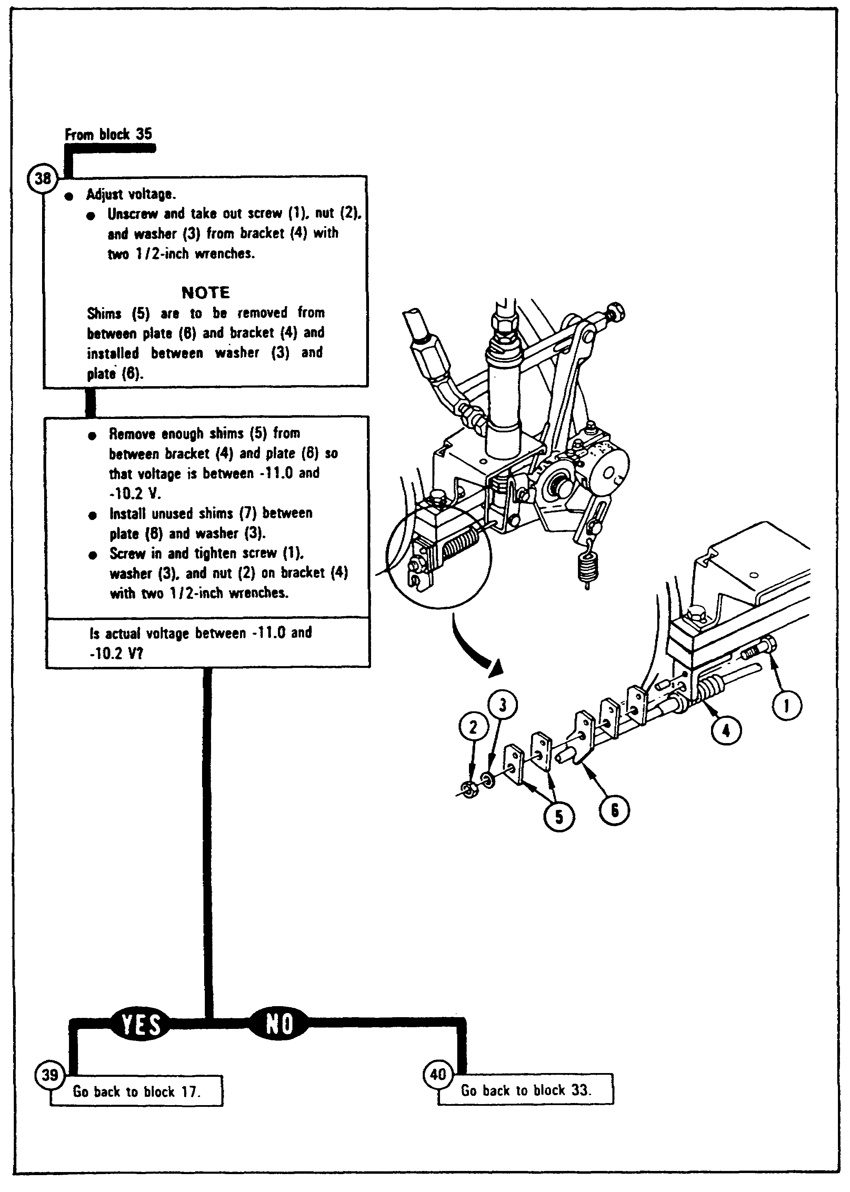
FIGURE 13. IGV ADJUSTMENT FLOW CHART
(CONTINUED).

35

IGV ASSY, M1 TANK - OD 0487 - LESSON 1/TASK 2

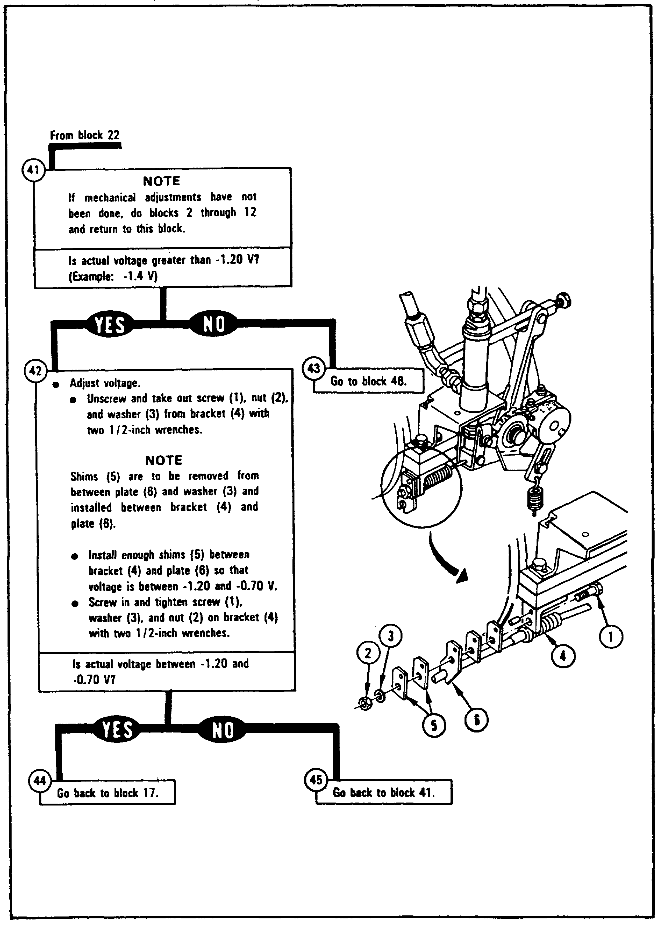
FIGURE 13. IGV ADJUSTMENT FLOW CHART
(CONTINUED).

36

IGV ASSY, M1 TANK - OD 0487 - LESSON 1/TASK 2

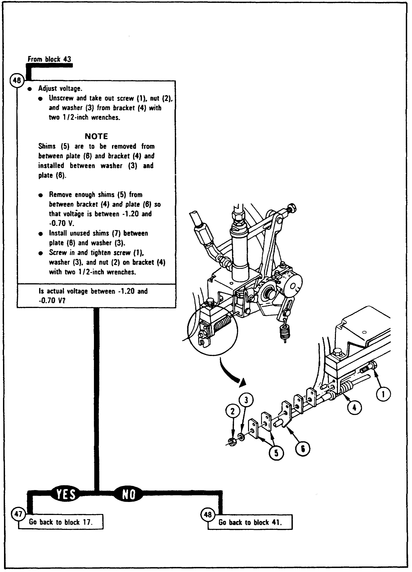
FIGURE 13. IGV ADJUSTMENT FLOW CHART
(CONTINUED).

37

IGV ASSY, M1 TANK - OD 0487 - LESSON 1/TASK 2

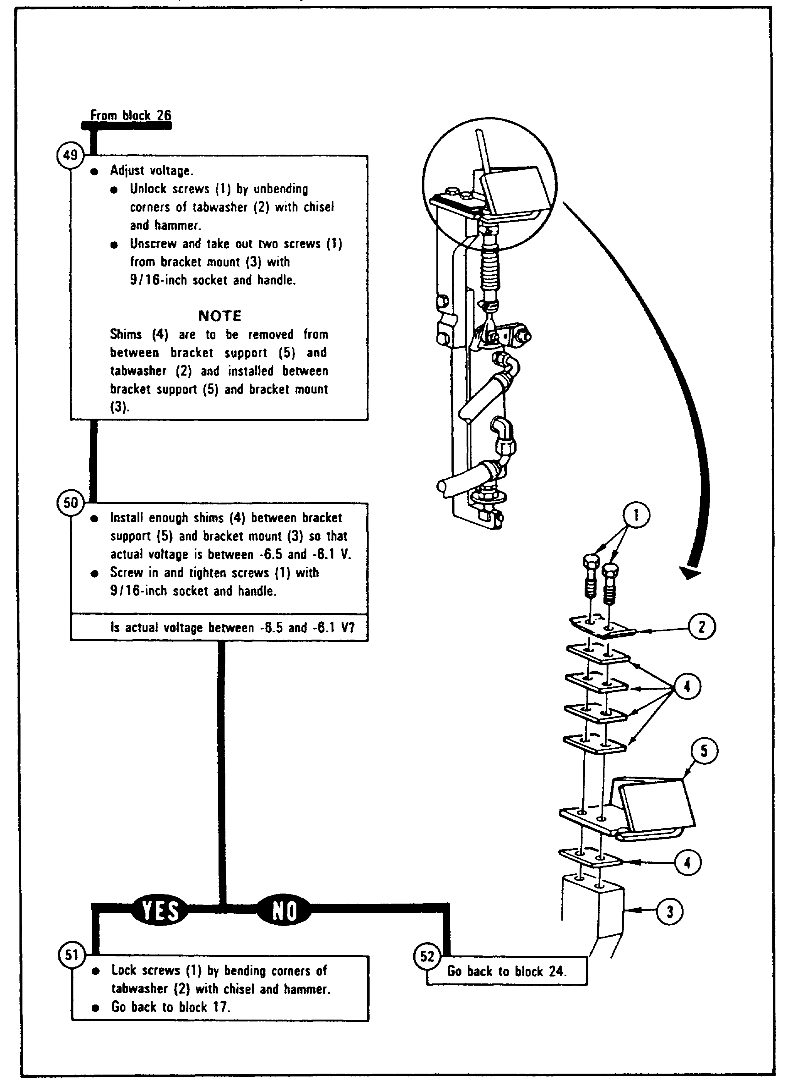
FIGURE 13. IGV ADJUSTMENT FLOW CHART
(CONTINUED).

38

IGV ASSY, M1 TANK - OD 0487 - LESSON 1/TASK 2

3. Conclusion

To keep the M1 tank's gas turbine engine from stalling at low speeds, the inlet guide vane (IGV) system deflects the air reaching the compressor, changing the angle at which the air strikes the compressor blades and keeping the engine from choking on its own air. The M1 Abrams tank systems mechanic is responsible for the proper adjustment of the IGV feedback voltages to keep the IGV system working properly and to keep the tank engine from being damaged due to improper operation.

39

IGV ASSY, M1 TANK - OD 0487 - LESSON 1/PE 1

PRACTICAL EXERCISE 1

1. Instructions

On a plain sheet of paper, write down the answers to the following questions. When you have answered them, turn the page and check your answers.

2. First Requirement

a. The steps to remove the inlet guide vane (IGV) shouldered shaft appear out of sequence below. Number your paper from (1) to (10) and write the steps on your paper in the proper order.

- Remove tube nut from elbow

- Remove bolts from left and right side of bracket

- Remove plug P7 from bypass filter pressure switch

- Disassemble and inspect shaft

- Remove tube nut from adapter

- Remove plug P9 from oil temperature transmitter

- Bend keywasher tabs away from left side bracket bolt

- Remove cotter pin from straight pin at bottom of shaft

- Remove bolts and lockwashers from underside of bracket

- Remove bracket and IGV shouldered shaft from vehicle

b. How many different actuator lever configurations are used on the M1 tank?

40

IGV ASSY, M1 TANK - OD 0487 - LESSON 1/PE 1

c. The installation procedures for the IGV actuator lever and link appear out of sequence below. Number your paper from (1) to (9) and write the steps on your paper in the proper order.

- Adjust shim and install retaining ring

- Push quick-release pin through control assembly and lever

- Place two straight pins and retaining rings through link and lever

- Place washer, lever, bearing, and shim on shaft

- Place actuator link on lever

- Connect lever and stud

- Secure straight pin to link and shouldered shaft

- Hook spring onto link

- Install screw, washer, spacer, and self-locking nut into link and lever

3. Second Requirement

a. The mechanic examines the IGV feedback voltage using STE. The SETCOM display shows ADJ IGV -11.O0/-10.2V -11.4 V. On which side of the plate does the mechanic place the shims until a voltage between -11.0 and -10.2 vdc is reached?

41

IGV ASSY, M1 TANK - OD 0487 - LESSON 1/PE 1

LESSON 1. PRACTICAL EXERCISE - ANSWERS

1. First Requirement

a. 1. Remove plug P9 from oil temperature transmitter

2. Remove plug P7 from bypass filter pressure switch

3. Remove tube nut from elbow

4. Remove tube nut from adapter

5. Remove cotter pin from straight pin at bottom of shaft

6. Remove bolts and lockwashers from underside of bracket

7. Bend keywasher tabs away from left side bracket bolt

8. Remove bolts from left and right side of bracket

9. Remove bracket and IGV shouldered shaft from vehicle

10. Disassemble and inspect shaft

b. Two

c. 1. Place actuator link on lever

2. Place two straight pins and retaining rings through link and lever

3. Place washer, lever, bearing, and shim on shaft

4. Adjust shim and install retaining ring

5. Push quick-release pin through control assembly and lever

6. Secure straight pin to link and shouldered shaft

7. Connect lever and stud

42

IGV ASSY, M1 TANK - OD 0487 - LESSON 1/PE 1

8. Install screw, washer, spacer, and self-locking nut into link and lever

9. Hook spring onto link

2. Second Requirement

a. The mechanic places the shims between the plate and the bracket.

43

IGV ASSY, M1 TANK - OD 0487 - REFERENCES

REFERENCES

44

IGV ASSY, M1 TANK - OD 0487 - REFERENCES

REFERENCES

The following documents were used as resource materials in developing this subcourse:

TM 9-2350-255-20-1-2-2
TM 9-2350-255-20-1-3-1

45

